LONDON BOROUGH OF BROMLEY


PROVISION OF FOOTWAY CROSSOVERS:

POLICY AND GUIDELINES

Adopted 12th January 2026

General principles

1. These Guidelines apply to the construction of new or extended crossovers which provide access to properties from the carriageway across footways and/or verges, under section 184 of the Highways Act 1980, and where the proposed crossover does not depend on the applicant requiring planning permission for an associated development.

2. Where planning permission is required, the need for a crossover and any detailed design considerations will be taken into account as part of the assessment of the planning application. However, many of the principles contained in these Guidelines will be relevant when considering whether to grant permission for a crossover and to its subsequent construction. Planning permission for crossovers will be required for multiple occupancy dwellings (e.g. flats, maisonettes etc) and for those on the classified road network. Even when planning permission is granted for works on a private property, a separate Vehicle Crossover Application will always be required for construction of a crossover.

3. The construction of a vehicle crossover does not give the occupier of the premises any particular rights, except to drive across the footway or verge to gain access to his/her property with a private or light goods motor car: the crossover itself is part of the public highway. The Authority does not guarantee that a crossover will be suitable for use by any particular vehicle (for example a vehicle with low ground clearance). The Authority reserves the right to impose reasonable conditions on the use of any crossover, as provided for in the Highways Act 1980.

4. The Authority reserves the right to review its policies, working practices and charges from time to time to ensure the continued provision of an efficient and cost-effective service.

Vehicle Crossover size limitations and construction materials

5. The standard surface material for Vehicle Crossovers shall be concrete modular block paving.

6. "Special" materials which vary from the above standard will be acceptable but only when the character of surrounding highway determines it is appropriate.

7. The full width of construction required for a Vehicle Crossover or extension to an existing Vehicle Crossover must be within the property boundary of the property applying and not overlap with neighbours.

8. Stand-alone Vehicle Crossovers for different properties are not built ‘back to back’ or ‘reducer kerb to reducer kerb’ so will require a 0.6 metre gap between the end of the neighbouring existing Vehicle Crossover and the start of the proposed Vehicle Crossover, even if the overall size of the proposed Vehicle Crossover has to be reduced to allow for this.

9. The maximum width of a stand-alone Vehicle Crossover shall consist of 3 metres of flat/lowered kerb with 0.9 metre reducer kerbs either side, making the overall width 4.8 metres at the highway boundary with the property. The 3 metres of flat/lowered kerb is the absolute maximum allowed.

10. The minimum width of a stand-alone Vehicle Crossover shall consist of 2.4 metres of flat/lowered kerb with 0.6 metre reducer kerbs either side, making the overall width 3.6 metres at the highway boundary with the property. The 2.4 metres of flat/lowered kerb is the absolute minimum allowed.

11. Permission for an application for a stand-alone Vehicle Crossover or an extension to an existing stand-alone Vehicle Crossover will therefore be refused if requesting more than the maximum of 3 metres of flat/lowered kerb allowed or if there is not the minimum required 3.6 metres available to install a new stand-alone Vehicle Crossover. For extensions to an existing stand-alone Vehicle Crossover the pre-existing amount of flat/lowered kerb will be included in the overall 3 metre maximum allowed, e.g. if the existing Vehicle Crossover already consists of 3 metres or more of flat/lowered kerb the application to extend would be refused.

Standalone Vehicle Crossover size limitations:
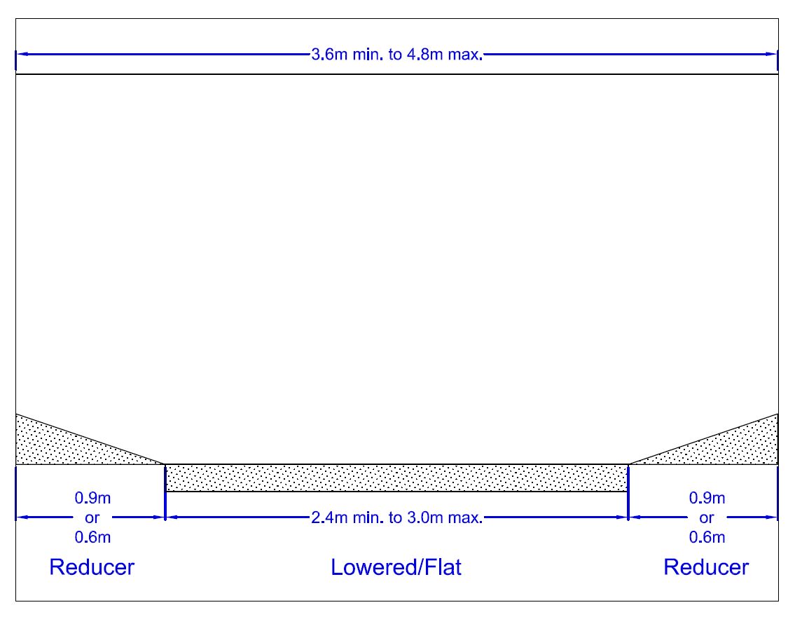

12. The maximum width of a shared Vehicle Crossover shall consist of 3.9 metres of flat/lowered kerb with a 0.9 metre reducer kerb at the end, making the overall width 4.8 metres at the highway boundary with the property. The 3.9m is measured from the property boundary that Vehicle Crossover is shared with. The 3.9 metres of flat/lowered kerb is the absolute maximum allowed.

13. The minimum width of a shared Vehicle Crossover shall consist of 2.4 metres of flat/lowered kerb with a 0.6 metre reducer kerb at the end making the overall width 3 metres at the highway boundary with the property. The 2.4 metres of flat/lowered kerb is the absolute minimum required.

14. Permission for an application for a shared Vehicle Crossover or an extension to an existing stand-alone Vehicle Crossover will therefore be refused if requesting more than the maximum of 3.9 metres of flat/lowered kerb allowed or if there is not the minimum required 3 metres available to install a new shared Vehicle Crossover. For extensions to an existing shared Vehicle Crossover the pre-existing amount of flat/lowered kerb will be included in the overall 3.9 metre maximum allowed, e.g. if the existing shared Vehicle Crossover already consists of 3.9 metres or more of flat/lowered kerb the application to extend would be refused.

Shared Vehicle Crossover size limitations:
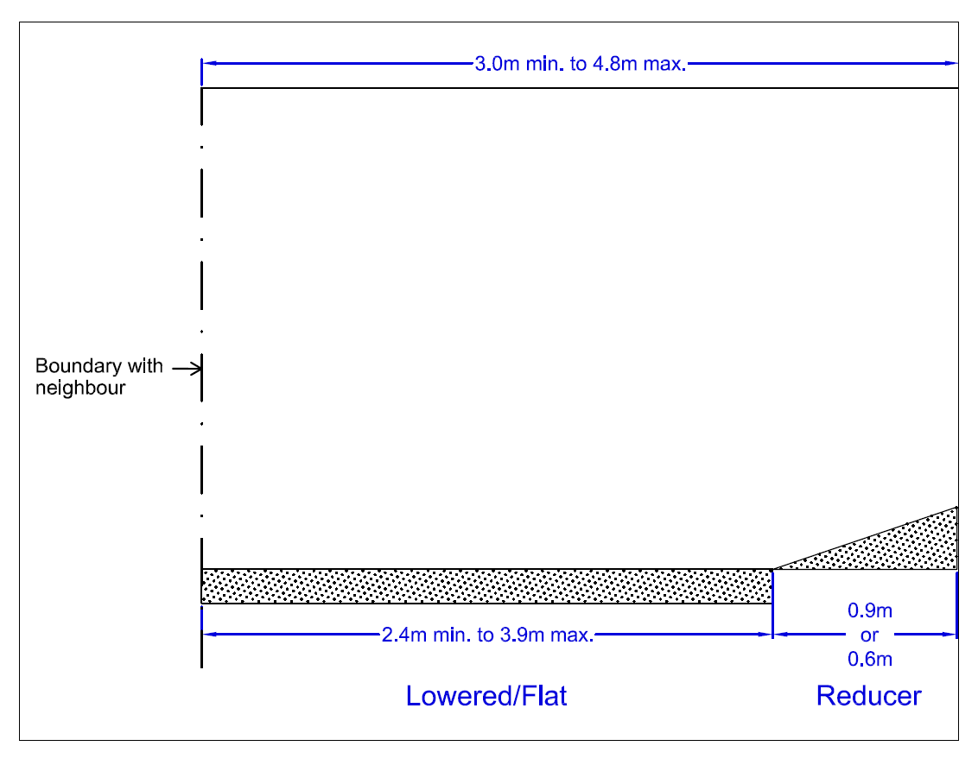

15. Applicants for Vehicle Crossover extensions are to be informed of any likely difference in the appearance of the new construction and given the opportunity to bear the costs of any special works to reduce the difference or to undertake a full width reconstruction/ resurfacing should they wish.

Minimum Parking Area standards

16. The Vehicle Crossover must be installed in line with the proposed parking area. Parallel parking to the carriageway shall not be permitted.

17. The required parking area must be at a right angle to the carriageway and must be a solid, unobstructed, even surface a minimum of 4.5 metres in depth from the back edge of the public footpath/Highway boundary and an unobstructed minimum of 2.4 metres wide throughout.

18. Where the planned parking area is located in front of a garage or access where an adequate means of escape needs to be provided, like a front/back door or pedestrian access route to a side door, an unobstructed minimum of 5.5 metres in depth from the back edge of the public footpath will be required.

19. Permission for an application will therefore be refused if any part of the property, parking areas retaining wall, any other obstruction, or parking areas solid even surface is less than 4.5 metres from the back edge of the public footpath/Highway boundary and /or less than 2.4m wide.

20. Permission for an application will therefore also be refused if the planned parking area is located in front of the adequate means of escape as described above and is less than 5.5 metres from the back edge of the public footpath/Highway boundary.

Examples of minimum acceptable parking area layouts:
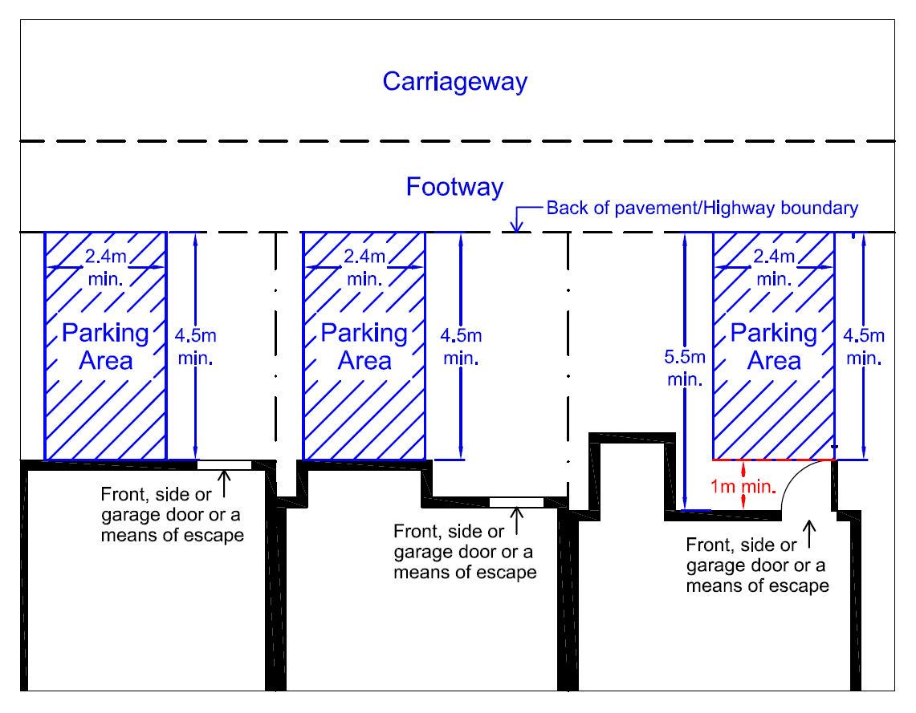

Example of acceptable parking layout for two vehicles:

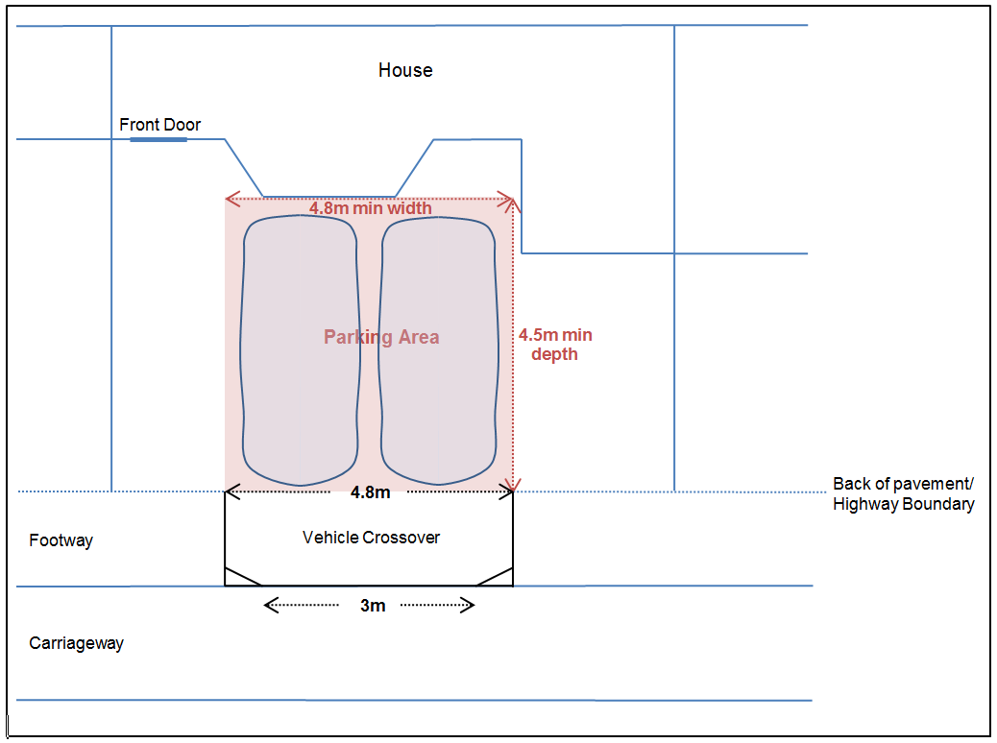

Verges

21. The Authority will endeavour to sustain grass verges and amenity areas maintained by the highway authority as an important and integral part of the Borough's street scene wherever possible. The Authority reserves the right to reject on amenity grounds an application for a Vehicle Crossover across a verge or amenity area.

22. Where they will adversely affect the amenity of the area, the provision of Vehicle Crossovers in highway verges and amenity areas shall be kept to a minimum, for example by combining more than one crossover.

23. When considering an application for a Vehicle Crossover or an extension to an existing Vehicle Crossover in a grass verge or amenity area greater than 4 metres in depth, the presumption shall be to reject it.

24. When considering an application for a Vehicle Crossover or an extension to an existing Vehicle Crossover in a grass verge or amenity area between 3 metres to 4 metres in depth the overall allowed square meter loss of grass verge or amenity area is capped at 14.4m². This means the maximum allowed width of Vehicle Crossover allowed will reduce on sliding scale from 4.8 metres over a 3 metre deep verge to 3.6 metres wide over a 4 metre deep verge. For extensions to an existing Vehicle Crossover the area already constructed across the grass verge or amenity area will be included in the overall 14.4 m² measurement allowed, e.g. if the existing Vehicle Crossover already covers 14.4m² or more of what would have originally been grass verge or amenity area the application to extend would be refused.

Conflict with street trees or planted areas

25. When an application is received to construct or extend a Vehicle Crossover, which has a direct or indirect effect on a highway tree or other “managed” planting, such as hedges’, no decision will be taken until the Council’s Arboricultural Officer or other appropriate officer has been informed and responded.

26. The general presumption will be to refuse an application if there is a conflict with a street tree and /or its surrounding root system. To avoid damage to the tree roots or rooting environment the Arboricultural Officer or other appropriate officer will decide a minimum root protection area around the tree. The root protection area will be used as the minimum acceptable distance between the tree and any excavation/construction.

27. Where a street tree has been damaged, unlawfully interfered with, or removed in suspicious circumstances, the Council will refuse, for a period of up to 10 years, any Vehicle Crossover application that would have been constrained by the original tree and/or its Root Protection Area. During this period, a replacement tree will be planted by the Council and allowed to establish. Approval will not be granted for any Vehicle Crossover that compromises the establishment of the replacement tree.

28. If the Arboricultural Officer or other appropriate officer, decides that a particular tree or planted area does not warrant retention for the benefit of the community or can be re-established elsewhere, the Contract Monitoring Officer will be told that its removal is approved and provided with the estimated cost. At the same time, the Arboricultural Officer or other appropriate officer will stipulate the number, type and costs for replacement trees/plants, as well as if any additional financial compensation for its removal is required. The number of replacement tree(s) and/or financial compensation required will depend on the amenity calculation of the value of the existing tree using the Capital Asset Value for Amenity Trees (CAVAT) valuation system’.

29. The cost of the tree/plant removal and the replacement(s), including initial maintenance, and any required financial compensation will be charged to the applicant as part of the Vehicle Crossover works.

30. When an existing Vehicle Crossover is obstructed/affected by a street tree to the obvious detriment of public safety, every effort will be made to resolve the conflict so as to retain the tree. However if this is not possible and public safety is being compromised, the tree will be removed and replacements planted. The cost of the tree removal and replacement(s) or Vehicle Crossover relocation and accommodation works will be borne by the Authority.

Conflict with private trees

31. When an application is received to construct or extend a Vehicle Crossover, and the officer making the initial site visit feels that the proposals would have an adverse affect on an established private tree, he will defer any decision to progress the Vehicle Crossover and refer the matter to the Arboricultural Officer. The Arboricultural Officer will consider the particular situation and inform the Contract Monitoring Officer of any advice and/or intended action. This could include the implementation of a Tree Preservation Order if it is felt that the loss of the tree(s) would be detrimental to the visual amenity of the area.

Conflict with street furniture

32. There should be no obstruction such as a telegraph pole, lighting column or above ground utility apparatus within 500 mm of the edge of the crossover.

33. Any repositioning, alteration and/or adjustment to street furniture or Statutory Undertaker's apparatus considered necessary and practical to help with the forming of an access shall be undertaken at the cost of the applicant.

34. If any repositioning, alteration and/or adjustment to Statutory Undertaker's apparatus is required which the Authority is unable to complete themselves the applicant is required to gain agreement directly from Statutory Undertaker's for them to undertake the work and pay any of their required costs.

35. If any Statutory Undertaker's apparatus is unable to be repositioned, altered and/or adjusted the proposed Vehicle Crossover size may have to be reduced/relocated. Permission will therefore be refused if there is not the minimum required space remaining to install a Vehicle Crossover as described earlier in this policy.

Provision of extra crossovers and ‘in and out’ drives

36. Where planning permission is required, the Chief Planner can reject applications in accordance with criteria in the Unitary Development Plan or Local Development Framework and on traffic safety criteria. Where planning permission is not required, requests for additional crossovers may be rejected on the basis that reasonable access already exits as a result of the construction of the first crossover and the common law right of access has been met.

37. Where there is no practical loss of on-street parking or amenity from an additional access and it is possible to park a vehicle between the two points of access, applications for additional crossovers will usually be considered favourably. The minimum space requirement to be considered for an extra crossover is 5 metres between the end of the existing Vehicle Crossover and the start of the proposed Vehicle Crossover with the proposed Vehicle Crossover still being constructed within the property boundary. With a minimum sized Vehicle Crossover’s total construction being 3.6 metres wide this means that to be considered for a second Vehicle Crossover there must be 8.6 metres between the end of the existing Vehicle Crossover and the property boundary. This assumes however that all relevant planning, highway safety and amenity criteria have been satisfied.

Safety and the free flow of traffic

38. The Authority is required by the Highways Act 1980 to consider safety and the free flow of traffic when considering whether to install a crossover. Among the matters likely to be considered are proximity to a road junction, visibility and sight lines, the existence of “zig zag” markings at the kerbside, the width of the street and traffic flow. This is not an exclusive list, and the Council will take into account any matter which appears relevant under this heading.

39. The Authority reserves the right to refuse any proposed Vehicle Crossover within 10 metres of the first radial kerb of any road junction. The general presumption will be to refuse any application for a Vehicle Crossover directly onto a road junction.

Applications in streets with, or proposed to have, controlled parking

40. The Authority reserves the right to take into account existing on-street parking provision when considering whether to permit a crossover. Where the proposed crossover would result in the removal of a marked on-street parking or loading bay, or the reduction in capacity of such a bay, there will be a presumption to refuse an application. In cases where it is possible to relocate or otherwise amend an on-street parking bay without disbenefit to the public, all costs will be charged to the applicant.

41. From time to time the Council responds to increased local parking stress by consulting on proposals to introduce new areas of parking control, or to extend or amend controls in existing controlled areas. The Council will not accept any applications (and will return any applications and cheques) from an area affected by proposals between the date of issue of the first consultation document or the date when a consultation was first proposed in a published Council agenda paper (whichever is the earlier) until such time as a final decision is taken to implement a scheme (or not implement it as the case might be). Once a scheme is agreed for implementation, but before it is implemented, any application will be considered as though the scheme had already been implemented.

42. The Authority will not provide a vehicle crossover until all necessary amendments to the Traffic Regulation Orders have been made so as to provide unimpeded access to the crossover and the application complies with the criteria set out in the Council's on-street parking policy.

43. The Authority will not promote an amendment to a Traffic Regulation Order to make a vehicle crossover until the appropriate fee has been received. Furthermore, the Authority does not warrant that the receipt of the fee will guarantee that any objections to amending an Order will be overruled or set aside.

Redundant crossovers

44. When it appears that an existing crossover is redundant (for example because a hardstanding has been replaced with soft landscaping or a boundary wall has been constructed) and the Authority is undertaking routine maintenance, or it otherwise appears expedient for the Authority to do so, the Authority will remove the crossover and reinstate the kerb and footway without charge to the frontage owner.

At other times the Authority will consider requests from frontage owners for reinstatement, at the frontage owner’s expense, where there is clear evidence that the frontage owner has already undertaken works to ensure that there is no continuing risk of vehicles seeking to cross the footway to access the premises.

In appropriate cases the Authority will also designate the area in front of the former crossover as parking space.

Fees and charges

45. Where an application is initiated by the applicant for his or her own benefit (that is, the proposed crossover is not necessitated by or consequent upon a scheme proposed by the Council for which there is an approved budget), the Authority will seek to recover from the applicant its full costs in considering the application (including where the application is unsuccessful) and providing / constructing a Vehicle Crossover and any necessary associated works.

46. The fees and charges will be regularly reviewed by officers, in light of relevant legislation/regulation, changes in contracts and changes in resource costs. Any revisions considered necessary will be implemented under delegated powers.

47. The Council will continue to offer residents a range of acceptable payment options.

Construction and maintenance

48. With the exception of special cases, where agreement is reached with officers to the contrary, all Vehicle Crossover construction will be undertaken by the Authority's term-maintenance contractor. From the date that the Council accepts the completed crossover, it will assume responsibility for its maintenance at no cost to the occupier, apart from any damage caused by illegal use by heavy vehicles.

Standard conditions to be met prior to construction

49. Once permission has been granted, and before any Vehicle Crossover construction begins, the applicant must ensure that an off-street parking area is installed in compliance with the following requirements:
- Surface Material:
  - The parking area shall be surfaced in a bound, durable material such as permeable concrete block paving, porous asphalt, or resin-bound gravel.
  - Loose unbound materials (e.g., loose gravel) are not permitted within 1 metre of the highway to prevent migration onto the footway/carriageway.
- Permeability and Drainage:
  - The surface must be permeable, or provision must be made to direct all surface water to a permeable or porous area within the property (e.g., lawn, border, soakaway, or rain garden).
  - Where the parking area slopes toward the highway, a channel drain or equivalent system shall be installed along the boundary to intercept runoff and discharge it to a suitable soakaway or drainage system within the property.
- Legal Compliance:
  - Under Section 163 of the Highways Act 1980, it is an offence to allow water from private land to discharge onto the highway. The applicant must ensure that no surface water flows onto the footway or carriageway.
- Inspection:
  - The Contract Monitoring Officer will verify compliance with these requirements before authorising crossover works. Evidence (e.g., photographs or site inspection) may be required.
- Non-Compliance:
  - Any application whose proposed parking area does not meet these requirements for surface material, permeability, drainage, and layout would be refused. Any parking area constructed under this Policy that is subsequently found not to comply may be subject to enforcement action, including installation of bollards to restrict access if alterations are not made to bring the parking area within standards.

50. No construction work shall be programmed and/or commenced until acceptable financial arrangements have been put in place and/or payment has been made.

Cost of construction offset by appropriate and relevant road and/or traffic works

51. When major footway maintenance works are being undertaken and provided there is not a conflict with any other Vehicle Crossover Policy, residents may be offered the opportunity of having an existing Vehicle Crossover extended whilst the works are in progress. The costs charged to the resident will be for only those additional works in forming the Vehicle Crossover.

52. Applicants need to check if their road is likely to qualify for the above in advance of making a normal Vehicle Crossover Application, or subsequently taking the Authority up on any supplied quote for construction, and decide whether to still proceed on that basis or wait to see if an extension is offered as part of major footway maintenance works.

Infringements involving existing crossovers

53. Redundant Crossovers – Although current procedures should now prevent it, there may be instances where an existing crossover has been constructed but the occupant has taken no steps to provide parking within their curtilage (examples include failure to remove boundary walls, hedges, trees, etc) and the crossover appears to have been used to reserve parking either on the carriageway or the crossover.

In the first instance, the occupant will be requested to construct a hard standing and gain access, or pay for the removal of the crossover. If the occupant does not respond or refuses to pay, the Authority may take steps to reinstate the kerb and footway in whatever manner it considers expedient and to reclaim any associated costs. This action may also include any temporary measures required to stop vehicles crossing the footway.

54. Illegal Footway Vehicle Crossovers - Where a driver habitually attempts to gain access to either a residential or commercial property by crossing the footway/grass verge where there is no constructed crossover, the Council has powers under section 184 (1) of the Highways Act (1980) to insist on the construction of a properly surfaced Vehicle Crossover, subject to meeting all relevant planning, highway safety and amenity criteria. The approach will be to notify the occupier in the first instance to make them aware of the legal implications and to advise them both to stop Vehicle Crossover the highway and to apply for a crossover in accordance with the stated procedures if the location would meet the requirements of the Vehicle Crossover Policy. If the occupant persists in crossing the raised kerb, footway, grass verge or amenity area, further action can be taken to protect the highway and to install preventative measures to restrict access.

Exemptions to parking on vehicle crossovers

55. A Vehicle Crossover is provided to gain vehicular access to the curtilage of a property (that is, it remains illegal to park on a highway where a crossover has been constructed, other than temporarily, as this obstructs the highway previously available to pedestrians). Where this occurs the Council's Parking Team has arrangements with its contractor to serve Penalty Charge Notices (PCNs) on vehicles parked in contravention of the borough-wide footway parking ban. Exemptions may apply to certain streets where vehicles can either park partly (with two wheels) or wholly (with all four wheels) on the footway. An exemption may also apply to streets with clearly defined pavement areas with long crossovers between the property boundary and the pavement. On no account will an exemption apply to parking on crossovers between the pavement and the edge of the carriageway.

Exemptions based on applicants' medical conditions

56. When an application has not been approved, the applicant may appeal on medical grounds, if either the driver or another occupant of the property is unable to walk any distance without suffering considerable discomfort. Appeals based on applicants' medical conditions will be referred to our Occupational Therapy department for advice.

Our Occupational Therapy department will only recommend that we waive sections of the Vehicle Crossover Policy if:

1. The applicant experiences severe mobility problems and there are serious and frequent problems parking near their home (due to e.g. busy road, near train station) or the carer experiences significant hardship getting the client from parking to the property safely (e.g. disabled child).
AND
2. The applicant has a Blue Badge
AND
3. Applicants under 65 years of age need to be receiving higher rate mobility component of Disability Living Allowance (DLA).
AND
4. A Disabled Parking Bay outside the property has been applied for and is not suitable due to technical reasons (i.e. although client may be eligible for a Disabled Parking Bay, it is not feasible to mark a parking bay due to the road layout and road safety aspects, as deemed by the Traffic Department).

Under these circumstances approval may be given which is personal to the person claiming exemption, and the applicant will be required to enter into an agreement whereby the Council has the right to reinstate the highway as a footway and remove the dropped kerb area of the crossover if the person for whom exemption was claimed ceases to live at the property. A nominal sum will be charged to the resident for the complete cost of these reinstatement works at the installation stage.

Appeal procedures

57. Should an applicant for the construction of a Vehicle Crossover be dissatisfied with the response (including but not limited to refusal of consent or any conditions attached to the use of the crossover), he or she may make representations to that effect. The matter will be reviewed in the first instance by the Highway Area Manager, who will assess whether these Guidelines have been properly and consistently applied. The Highway Area Manager will determine either:
- that the Guidelines have been correctly applied; or
- that the Guidelines have not been correctly applied, and propose a remedy to the applicant.

Where the sole reason for refusal of an application is a conflict with a street tree or its surrounding root system, the following additional appeal considerations shall apply:

- Arboricultural Review
At the first-stage appeal, the Arboricultural Manager or other appropriate officer will review the originally assessed Root Protection Area (RPA). If the identified conflict falls only within the outer 30% of the reviewed RPA, the Arboricultural Manager or other appropriate officer may, at their discretion, offer the option for an investigatory trench to be dug to assess whether any essential roots are present within the area required for the Vehicle Crossover construction.
This option is not available where the conflict lies within the inner 70% of the RPA.

- Discretionary Offer Only
Whether an investigatory trench is offered will depend on factors such as tree species, location, age/condition, and site constraints.
It may not be offered in all cases, even where the conflict lies within the outer 30% of the RPA.

- Costs and Arrangements
  - Where offered, the investigatory trench will be provided at a fixed cost, confirmed at the time of offer, and payable in full in advance by the applicant.
  - The Council will not undertake investigatory trenches at its own cost.
  - All investigatory trenches must be carried out by the Council’s own contractors under the direct supervision of the Arboricultural section.

- Outcome Determination
  - The assessment of whether essential roots are present will be made solely by the Council’s Arboricultural section.
  - External or private arboricultural opinions are not required and will not be considered as part of the appeal process.

- Effect on Appeal
  - If the option of an investigatory trench is offered but not taken up by the applicant, the appeal assessment will revert to the full 100% of the reviewed RPA.
  - If essential roots are found during the investigatory trench, the original refusal (based on the full RPA) will stand.
  - If essential roots are not found, any Vehicle Crossover subsequently approved will be based on the minimum allowable width under the policy so that works are kept as far from the tree as possible.

The outcome of the review will be communicated to the applicant within 90 days of representations being received, together with notification of their right to appeal further if desired.

58. If an applicant exercises the right to appeal further, the matter will be referred to the Assistant Director (Highways), or in his absence another Assistant Director. In determining the appeal, the Assistant Director shall have regard to:
- the decision of the Highway Area Manager and whether it is correct;
- any other matter which the applicant has cited as grounds for appeal, including, but not limited to, matters contained in these Guidelines; and
- whether any proposed decision provides an appropriate balance of benefit between the applicant and the community.

The outcome of the appeal will be final, and will be communicated to the applicant, with reasons, within 90 days of the appeal being received.

59. Where planning permission is required and the application is refused residents will still have a statutory right of appeal dealt with the Planning Inspectorate and notes of explanation are provided when the Town Planning Division issues a refusal notice. For the avoidance of doubt, the grant of planning permission does not supersede or confer Highway Authority consent for works in the public highway. Any new or altered vehicular access (dropped kerb/vehicle crossover) still requires approval under section 184 of the Highways Act 1980, and may be refused on Highway grounds irrespective of the planning outcome.

