=



**School Street Marshal Guidance**

Table of Contents

What is a School Street and how do they work? 3

Why is a marshal required? Recruiting marshals 3

Who can enter a School Street? 3

Operational timings and locations 5

Before and during the closure

Before the closure and manning the barriers 6

Escorting vehicles 7

Dealing with entry requests 8

Reporting incidences 9

Insurance 9

After the closure 9

Monitoring 10

Appendix 1 - Reporting Incidences 12

Appendix 2– Manual Handling of Loads 13

What is a School Street?

School Streets are where vehicle access is temporarily restricted on the road, outside school, specifically between school drop off and pick up times during term time.

## 

How a School Street works

School Streets are installed by using moveable barriers to restrict vehicles from entering the road at the start and end of the school day. These barriers are moved by marshals.

Why is a marshal required?

Marshals help to ensure that only drivers with permission to enter (e.g., residents displaying a permit, blue badge holders, emergency services etc) have access to the restricted pedestrian and cycle zone during the controlled period. They can also inform individuals about the scheme and provide guidance on what to do when using the School Street.

A School Street must always be marshalled. The marshal should remain on the pavement at all times unless access is required, or a vehicle wishes to exit the restricted area. The barriers **must NOT be left unattended at any time.**

Recruiting marshals

Schools are responsible for sourcing and managing their School Street Marshals.

Individuals identified as suitable marshals need to:

* Complete the online registration form
* Read and understand this Marshal Guidance
* Read and understand the London Borough Bromley’s and School’s risk assessments

Who can enter the School Street?

Only residents or those who hold a valid permit can enter the School Street during the restricted times. There may be a few parents who have a permit for children with Special Educational Needs and Disability (SEND). These will be issued directly by the school.

However, there are some exemptions for those who do not have a permit:

* Emergency services, community-based health and social care and patient transport ambulance vehicles
* Blue Badge holders
* Statutory public services, such as gas/electricity companies
* Refuse collectors
* Universal postal service providers, such as the Royal Mail
* Breakdown and recovery vehicles (the so-called 4th emergency service)

In circumstances where someone requires access to a resident’s property for a particular period, e.g., builders, decorators or short-term healthcare workers, the resident will be able to apply for a temporary permit which will show an expiry date.

Please note, any vehicles already parked within the School Street restriction prior to the closure will still be able to **exit** the street at any time.

Operational Timings and Locations

Each School Street must operate within the times specified in the Traffic Order and displayed on the School Street road signs. All School Streets operate Monday to Friday, term time only. Term times may vary from school to school.

**PLEASE NOTE, A SCHOOL STREET CAN ONLY BE OPERATIONAL DURING THE TIMES SPECIFIED BELOW. IF YOU OPERATE OUTSIDE OF THE PRESCIBED TIMES, THIS WILL RESULT IN AN ILLEGAL ROAD CLOSURE. FAILURE TO COMPLY, COULD RESULT IN THE WITHDRAWAL OF THE SCHEME.**

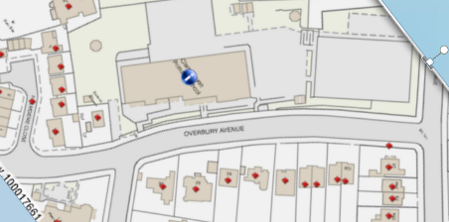

**Clare House Primary School:** Overbury Avenue, 08:30-09:00 and 15:00-15:30

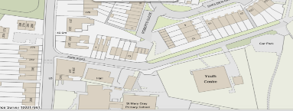

**Hayes Primary School:** George Lane, 08:15-09:15 and 14:45-15:45

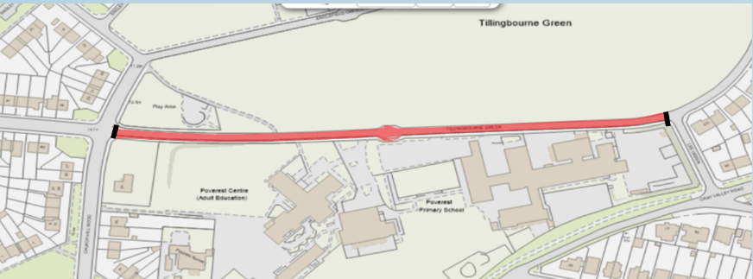

**Poverest Primary School:** Tillingbourne Green, 08:20-08:50 and 14:50 to 15:20

Before the closure

For marshals that are not based within school, they should sign-in with the school before they are due to man the barrier. Please note this depends on what the Head Teacher has agreed for their school marshals.

The marshal should be fit and well, and suitably dressed for the weather conditions. If the marshal is unwell or late for their arranged shift to man the School Street, please contact the school as soon as possible.

The school has been provided with a number of barriers, a chain, and a padlock. When transporting the barriers to the closure point, please ensure you follow the Manual Handling of Loads Guidance: Appendix 2.

Once at the closure point, please ensure the barriers are in place for the start of the restriction times so the road is restricted as per the times on the official road signage.

Once the barriers are placed in the road, please remain on the pavement whilst manning the barriers and do not leave them unattended until the restriction is over.

During the closure - Manning the barriers

* Please adhere to the School and London Borough of Bromley’s risk assessment, which you MUST read and understand when registering as a marshal
* You must wear the hi-vis tabard and carry a whistle which, the Council have provided at all times and wear sensible clothing and footwear.
* You should remain on the pavement at all times whilst manning the barriers unless access is required, or a vehicle wishes to exit the restricted area.
* If you are required to enter the highway, please be aware of any uneven surfaces on both the pavement and highway.
* Vehicles with permitted access will display theirSchool Street permit on the vehicle’s dashboard.
* Should a vehicle with permitted access wish to enter the street, you should move the barrier and allow them to do so. Ask that they please drive carefully and be aware of children and parents walking, scooting or cycling on the road. Move the barrier back into position once the vehicle has passed.
* You will also need to move the barriers for any vehicles wishing to exit the School Street.
* A permit is not required to exit the School Street and vehicles can exit at any time.
* **Parents should remain with their children at all times** until they have entered the school site.
* There must always be someone manning the barrier for any time the physical barrier is in place. If you do need to leave the barriers for any reason, please remove any equipment being used to close the street. **Never leave the barriers on the highway unattended.**
* **Please note: if you remove the barriers** the Pedestrian & Cycle Zone will remain in effect during the times indicated on the signage.

Only individuals that have:

* Completed the online registration
* Read and understood this Marshal Guidance
* Read and understood London Borough of Bromley’s and School’s risk assessments can operate as a School Street marshal

During the closure - Escorting vehicles

* Please note, it is not necessary for vehicles to be escorted within the School Street.

During the closure - Dealing with entry requests

* If a vehicle without permitted access wishes to enter the street, politely explain that they are unable to do so whilst the closure is in place (as indicated on the road signs).
* In the very unlikely event of someone attempting to drive through a road closure barrier, please act swiftly to ensure your own safety.
* Do not stand in front of any vehicles, let them enter.
* Make sure anyone else in the area is alerted so that they can move to the pavement.
* If you are able to do so, please take a note of the vehicle’s registration number (and if possible, a photo) so that this can be reported to the Police.
* At no point should you attempt to physically stop a car from entering the School Street.
* If you encounter an aggressive driver, try to remain calm and polite at all times.
* Explain to the driver the purpose of the road closure and that this is being done legally, with approval of the Council, which is enforceable by the Police.
* You should refer to the signage that is in place if you feel appropriate.
* If you feel that the situation is not resolving itself, try to seek assistance from anyone else in the area that can help reiterate these points.
* **If you fear for your own or others’ safety at any point, please call 999 or 101 immediately.**
* Report incidences immediately to the Head Teacher
* In the case of an emergency and you need to clear the road, please use the whistle provided.

Reporting Incidences

* It is imperative that any incidences that occur are reported to the Head Teacher and recorded in a School Street log.
* See Appendix 1 for an example ‘School Street Incident Log’ template.
* Although rare, the procedure for all serious incidents such as drive-throughs is:
  + They must be reported to the Head Teacher and recorded in the School Street Log.
  + The incident must be reported by the Head Teacher to the Road Safety Team within 24 hours via this mailbox.

[**schooltravelplans@bromley.gov.uk**](mailto:schooltravelplans@bromley.gov.uk)

Insurance

School Streets is a London Borough of Bromley initiative. In order to be covered by Bromley’s Public Liability insurance, marshals must:

* Be registered for the scheme and agree to the terms and conditions.
* Operate in accordance with the London Borough of Bromley’s risk assessment and this marshal guidance.
* Operate only to the times and location specified on the signs and Traffic Management Order.
* Failure to comply could invalidate the insurance.

After the closure

* Remove the barriers used to close the street and return them to the agreed storage place.
* Ensure that anyone using the road is aware that the road has now returned to normal operation.

Monitoring

You must make a log of any incidences in the school street incident log and report to the Head Teacher. See Appendix 1 Template ‘School Street Incident Log’.

* Serious incidences must be reported to the Council and if necessary to the Police by the Head Teacher.
* This will allow further investigation to take place.
* We will communicate with the school on a regular basis.
* We will also carry out regular site visits to answer any queries you may have.
* Our email address is: [schooltravelplans@bromley.gov.uk](mailto:schooltravelplans@bromley.gov.uk) should you need to contact the team directly.

The Road Safety Team will carry out routine visits to the School Street and if they find the scheme is not operating as per the risk assessment and terms and conditions, they will notify the lead school contact of their concerns to give the school the opportunity to rectify the situation.  The team will revisit the scheme to ensure that the scheme is operating correctly and if it is not, for the safety of everyone involved, this could result in the scheme being suspended or ultimately closed.

**School Travel Plan Team**

[**schooltravelplans@bromley.gov.uk**](mailto:schooltravelplans@bromley.gov.uk)

**bromley.gov.uk/schoolstreets**

Appendices

**APPENDIX 1 – Reporting Incidences**

**School Streets Incident Log – Example Template**

It is very important that all serious incidences are recorded in the log below and reported to the Head Teacher. Serious incidences (although rare) must be reported to the Council and if necessary to the Police by the Head Teacher within 24 hours.

Please contact: [schooltravelplans@bromley.gov.uk](mailto:schooltravelplans@bromley.gov.uk)

|  |  |  |  |  |  |  |
| --- | --- | --- | --- | --- | --- | --- |
| **Date** | **Time** | **Name reporting** | **Location**  **of**  **incident** | **Details of incident** | **Reported to LBB Y/N. Date** | **Reported to Police Y/N. Date** |
|  |  |  |  |  |  |  |
|  |  |  |  |  |  |  |
|  |  |  |  |  |  |  |
|  |  |  |  |  |  |  |
|  |  |  |  |  |  |  |
|  |  |  |  |  |  |  |
|  |  |  |  |  |  |  |
|  |  |  |  |  |  |  |
|  |  |  |  |  |  |  |
|  |  |  |  |  |  |  |

 **APPENDIX 2 – Manual Handling of Loads 2.07**

**1. INTRODUCTION**

The Manual Handling Operations Regulations 1992 apply to a wide range of manual handing activities including lifting, lowering, pushing, pulling or carrying by hand or bodily force of goods, equipment and people. The load may be either inanimate – such as a box or a trolley or animate – such as a person or an animal.

There is no such thing as a completely safe manual handling operation and the purpose of this guidance is to eliminate hazardous manual handling situations so far as is reasonably practicable.

***The Manual Handling Operations Regulations require employers to*:-**

**Avoid** the need for hazardous manual handling so far as is reasonably practicable.

**Assess** the risk of injury from any hazardous manual handling that can’t be avoided. **Reduce** the risk of injury from hazardous manual handling so far as is reasonably practicable.

**2.** **RISK ASSESSMENT**

Where manual handling operations cannot be avoided managers must make a careful assessment of manual handling risks that staff are exposed to. The most important thing to remember in all assessments is to identify all significant risks of injury and decide the most practical way to reduce the risk so far as is reasonably practicable.

When assessing manual handling risks, the order of priority should be: -

* eliminate the need for manual handling so far as is reasonably practicable
* provide mechanical aids to assist with the task
* reduce the frequency of such task(s)
* ensure all employees involved in manual handling are suitably trained for the task
* monitor the control measures introduced and keep the assessment up to date

If individual employees report adverse symptoms, become ill, injured or disabled or return to work following a long period of sickness, they may be more vulnerable to manual handling injuries, the manager should then refer the employee to Occupational Health to establish if s/he is fit enough to continue moving and handling tasks.

* An individual risk assessment may be required for employees with a specific need or disability
* An individual risk assessment must also be carried out for a new or expectant mother. Please refer to section 2.15 (New and expectant mothers) of the Corporate Health and Safety Manual.

Factors which can cause back injury include:

* lifting heavy items
* working in an awkward, unstable or crouched position, including bending forward, sideways or twisting the body.
* lifting at arm’s length or lifting an uneven load.
* lifting with a starting (or finished) position near the floor, or overhead or at arm’s length.
* handling unstable items.

**3.** **DUTIES OF MANAGERS**

Managers should ensure that, for work under their control:

* manual handling operations, which present a risk of injury are identified;
* manual handling operations, which present a risk of injury are avoided, so far as is reasonably practicable, by eliminating the need for the load to be moved or by the introduction of mechanisation e.g. trolleys;
* all new work, which may involve manual handling operations is assessed and safe systems of work implemented before the work commences;
* annual reviews of assessments are made to ensure that they are still valid, and reassessment carried out immediately if any of the components of the work situation change;
* staff recruited to posts involving manual handling should be suitable for the work they are required to do.
* suitable information, training and supervision is provided for all employees engaged in manual handling tasks and that the training is recorded, monitored, evaluated and reviewed.
* premises not owned or managed by the LBB at which employees may have to perform manual handling operations are safe and free from risk so far as is reasonably practicable.

**4.** **DUTIES OF EMPLOYEES**

The co-operation of employees is essential in reducing and eliminating the risk(s) from manual handling. Staff should therefore ensure that they comply with the following requirements:-

* Employees should follow the safe system of work designed and introduced by their managers and should not deviate from this without good reason.
* They should use mechanical aids, which have been provided for their use and for which they have been trained. Any faults with mechanical aids should be immediately reported to their manager.
* They should assist and co-operate with the risk assessment process.
* They should report all accidents, incidents, including near misses, which either caused or could have caused injury.
* They should inform their manager if they are unable to undertake their normal manual handling duties because of injury, illness or any other condition.

All employees have a responsibility to identify a potentially hazardous manual handling situation and should contact their manager to set the following process in motion.

**5.** **INFORMATION, INSTRUCTION AND TRAINING**

It is a legal requirement for all employees to be provided with information, instruction, and training, this is an essential component of risk management. Because it is not always possible to avoid manual handling tasks, it is essential that training in safer handling techniques is provided.

**6. OCCUPATIONAL HEALTH UNIT**

Prospective employees who declare a history of back pain will be medically assessed by Occupational Health as part of the pre-employment health assessment. Staff may be referred to Occupational Health if they develop back problems.

**7. ACCIDENT/ INCIDENT REPORTING**

All accidents relating to manual handling injuries should be reported using the LBB accident/incident report form AR3 this is available on the staff intranet at: http://onebromley to ensure compliance with Reporting of Injuries Diseases and Dangerous Occurrence Regulations (RIDDOR), all accident report forms should be forwarded to Corporate Health & Safety within 5 days, email: [central.safety@bromley.gov.uk](mailto:central.safety@bromley.gov.uk). Telephone 020 8313 4685.

**8. CORPORATE HEALTH & SAFETY**

Corporate Health & Safety will: -

* carry out planned inspections of health and safety, which will include checking that risk assessments, safe systems of work, and training records are in place and up to date.
* when requested, will assist managers in carrying out or revising risk assessments and help them to identify options for the control of risk;
* investigate accidents/incidents on request from managers or where the accident is reported to the HSE under RIDDOR.

**9. GOOD PRACTICE WHEN MANUAL HANDLING AN INANIMATE LOAD**

Lifting and moving loads manually are the biggest cause of injury, so it is important to make use of any lifting equipment that is provided. It is important when lifting, to use the right method.

* Written instruction or procedure should always be followed.
* Risk assessments, which have assessed the task and load, should be in place.
* Plan your route taking into account resting places and destination.
* Warm up your muscles before carrying out any difficult task and wear any personal protective equipment prescribed.
* Get close to the load and stand with the feet apart for stability
* Bend the knees sufficiently to grasp the item and provide leverage.
* Grip with the whole of each hand. · Use the strong muscles in the legs, not the back, to stand up and lift the load. · Keep the arms and legs close to the body and clasp the load to you as close as possible.
* Lower the load using the same principles (bending the knees keeping the load close with a firm grip).

Moving and handling people requires specialised training, please contact Corporate Health & Safety for further advice.

**GENERAL RISK ASSESSMENT GUIDELINES**

There is no such thing as a completely ‘safe’ manual handling operation. But working within the following normal lifting guidelines will reduce the risk.

**Guidelines for carrying**

When carrying a load, these guidelines will apply where the load is held against the body and is carried no further than 10m without resting. A more detailed assessment risk assessment should be made if a load is carried over a further distance or if the hands are below knuckle height.

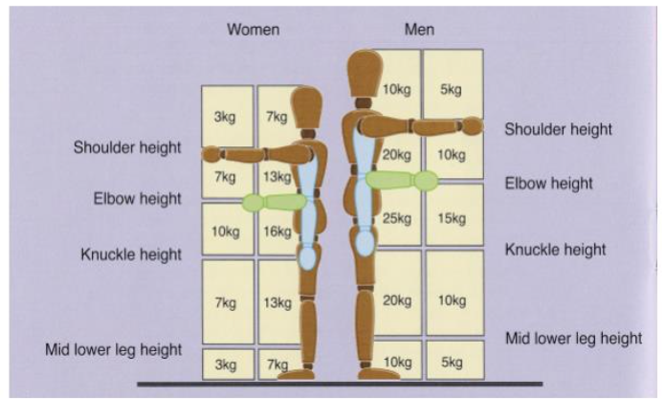

Ref: Manual Handling and Lifting Regulations 1992

HSE Five steps to risk assessment

Lifting Operations and Lifting Equipment Regulations 1998 (LOLER)

Provision and Use of Work Equipment Regulations 1998 (PUWER)