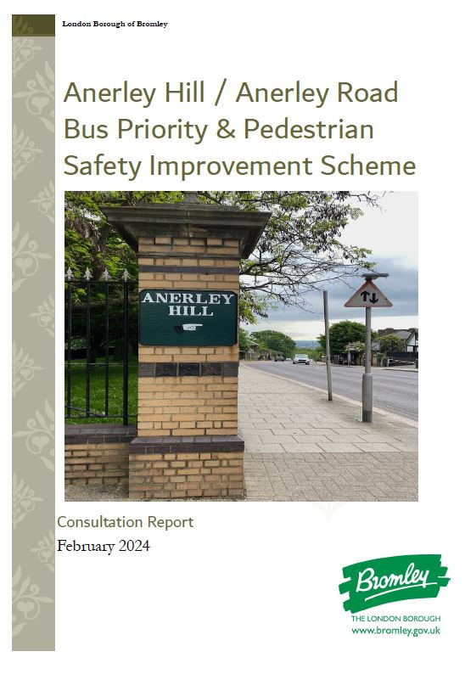
Executive Summary

Introduction
The London Borough of Bromley (LBB) is proposing to implement measures to improve bus punctuality and reliability, along with pedestrian safety improvements on Anerley Hill and Anerley Road between Crystal Palace Parade and Seymour Villas.
This scheme was identified as part of Transport for London’s (TfL’s) Bus Action Plan which sets out the long-term aspiration for a modern bus network capable of attracting more customers and helping Greater London to become net zero by 2030. In order to help achieve that, the Action Plan has an objective of delivering 25km of new bus lanes by 2025 to prioritise bus journeys and improve journey times.
TfL’s Bus Priority Programme provides targeted investment within Greater London to address pinch points and known reliability issues that affect the performance of the bus network. Through delivery of individual or corridor-based schemes, the programme aims to improve bus reliability, reduce journey times and, ultimately, improve customer experience and patronage.
In accordance with Bromley’s latest Transport Improvement Plan the Council also wishes to see the bus network run efficiently and reliably for the many residents and visitors who use and depend on it and see measures such as this as a very important means of helping achieve that.
The scheme also offers safety improvements for pedestrians at side road junctions along Anerley Hill and Anerley Road through the introduction of ‘Copenhagen’ style crossings, which are effectively continuous footways across side road junctions to give priority to pedestrians. Additionally, provision will be made for new areas of verge and trees to improve the public realm where space allows.

Key Elements of the Proposed Scheme include:
- Several lengths of bus lane to give priority to buses (within the current road space)
- Continuous pavement ‘Copenhagen’ crossings at side road junctions
- The re-designs of the Terrace Straight and Anerley Park junctions to make it easier and safer for pedestrians to cross.
- A new pedestrian crossing immediately to the north of the Terrace Straight junction.
- Additional car parking near the junction of Hamlet Road to help support local businesses.

Purpose
A key element of the development of this scheme was a public consultation with the objective:
- To give stakeholders and the public easy to understand information about the proposals and allow them sufficient time to respond.
- To understand the level of support or opposition for the proposals.
- To understand any issues that might affect the proposals of which we were not previously aware.
- To understand concerns and objections.
- To allow respondents to make suggestions.

Who we consulted
We sought the views of residents and businesses located along Anerley Hill and Anerley Road including residents who live in the side roads adjacent to Anerley Hill and Anerley Road. We also consulted with Councillors and Stakeholders including the Crystal Palace Park Trust and emergency services.

Dates and duration
The consultation ran for 21 days commencing on 11th January 2024 and closing on 1st February 2024.

What we asked
The consultation survey contained the following questions:
- Are you in favour of the proposed introduction of bus priority lanes along Anerley Hill/ Anerley Road to improve bus service reliability?
- Are you in favour of the proposed Copenhagen style crossings to improve pedestrian accessibility on the side road junctions with Anerley Hill/Anerley Road?
- Are you in favour of the proposed additional parking to serve local businesses near to the junction of Hamlet Road?
- Any further comments?

Methods of responding
Residents were invited to respond to the consultation by either accessing the online survey through a QR link, writing to us or by emailing, traffic@bromley.gov.uk

Consultation materials and publicity
People were invited to share their views via our webpage and complete the online survey.

Letters
Letters (Appendix 1) were distributed to publicise the consultation to over 4000 residents and businesses within the consultation area (Appendices 2.1 and 2.2).

Website
The consultation was published online via the London Borough of Bromley website at Bromley.gov.uk/consultations. The webpage explained what was being proposed along with the link to the survey page where the detailed consultation drawings (Appendix 3) were available to view.

Public Exhibition
A public consultation was held at Anerley Town Hall on Tuesday 23rd January 2024 between 2.30pm and 7.30pm. This provided an opportunity for all residents, local businesses, and Stakeholders to attend and view the detailed drawings in a larger format, make any comments and ask any questions regarding the proposal with the Lead Engineer, Transport Engagement Officers and Local Councillors.

Responses
Approximately 35 residents and Stakeholders attended the public exhibition, and we received 210 responses to the consultation. Of these respondents, 140 were located within the consultation area with the remaining 70 respondents located outside the consultation area.
98% of respondents are Residents and 2% of respondents are Businesses.

The responses to each question are as follows:

Survey responses from Residents and Business Owners within the Consultation Area

Overall survey responses from Residents and Business Owners

Survey Comments
Respondents were also asked for additional comments as part of the survey. There were many positive comments received regarding the proposed scheme which include:
“It all looks great and is much needed, both for buses and local parking possibilities. Moreover, it's going to improve the general appearance of the whole area. I'm very much in favour.”
“Anerley Road is a very busy road and is dangerous to cross if you don't use the lights. I am in favour of anything that will reduce the amount of traffic and improve safety on this road.”
“Very good news hope it works. Well done Bromley Council. I have lived in this area for a very long time, and I love it. All in favour of keeping public and transport moving Safely.”
“This is much needed. I cross from Hamlet to Thicket Road with my young daughter on the way to the park and music lessons, a really uncomfortable feeling. Crossing near the Thicket Road junction is appalling and a real hazard. Cars speed up Anerley Hill and given the parking of cars on both sides of roads, the speeding down Thicket Road is a real hazard. Prioritization of pedestrians is much needed. Anything to improve local transport infrastructure is also most welcome.”
“Please make this happen. It’ll bring great outcomes to residents and local businesses within Anerley Road and Anerley High Street! Thanks for bringing this to the table!”
“Very much in favour of increasing pedestrian safety at road crossings (this Copenhagen style looks good) especially given the number of children doing daily school run to James Dixon and other local Schools. Also, very much in favour of the zebra crossing near Versailles Road which hopefully will slow traffic down on that section of Anerley Road. Currently many people speed excessively and there have been many accidents around the Thicket Road junction. Also, in favour of parking measures that will support local businesses. In theory supportive of bus lines provided they don’t make the traffic worse.”
“Really good ideas and can’t wait for them to be implemented. Thicket Road DESPERATELY needs safety measures! Speed bumps. Speed cameras etc”
“The Copenhagen-style crossings are great proposals. This will underline the recent change to the Highway Code giving pedestrians the right of way at junctions where vehicles are turning into side roads (e.g., the junction of Hamlet Road and Anerley Road, which is change that is largely ignored by motorists at that junction).”
“Great initiative to improve pedestrian safety especially the Hamlet Road crossing is not working well at the moment for us on foot with a buggy.”
“This will greatly aid the local families and commuters in the area, as well as increase the safety of our local school children.”
“I like the plans generally and the zebra crossing to the north of Thicket Rd and Versailles Rd is a valuable change and make it much safer to cross.”
“My closest post office is near Hamlet Road and the parking is horrible, so this is welcome news. Some cycle parking near the post office Hamlet Road would be amazing because currently you must drive or walk but the walk is long, cycle parking would reduce my car trips! Hopefully the bus lanes help improve reliability on a congested road.”

We also received responses from residents and business owners who raised the following concerns about the scheme:

Negative impact on cyclists and reservations against the narrowing of lanes at top of Anerley Hill/Terrace Straight
“We have many cyclists that use Anerley Road regularly and in their thousands across a year. There are currently no cycle lanes, and your proposal of bus lanes would further give priority to vehicles. Cyclists have not been considered and they need to be given the number on this stretch of road.”
“Anerley Hill is used by many cyclists; parking should be taken off completely and allow for a cycle lane.”
“As a regular cyclist up and down Anerley Hill. I am very much in favour of the wider proposals. I do not, however, think the informal crossing point just up from the Terrace Straight entrance to the NSC should be narrowed as proposed as this would make it more dangerous for cyclists at that point. In fact, I think the proposals as put forward at this spot may not be in accordance with the Mayor's London Cycling Design Standards.”

“Anerley Hill and Anerley Road are heavily used by cyclists in both directions. The proposed island at the junction with Terrace Straight creates a potentially dangerous pinch point for cyclists. Going down the hill the gradient makes it hard to indicate a left turn into the park as both hands are needed to brake, and this will be more so with the tighter turn. With the narrower lane now there is an increased risk of being hit from behind by cars if slowing to turn. When coming uphill cyclists will be very slow because of the gradient and again the pinch point will increase the risk of drivers attempting dangerous close passes at or ahead of this point.”

“The proposed layout would make cycling on Anerley Hill far more dangerous by providing less space for motorists to overtake slow moving bicycles. This would encourage drivers to either wait behind a bicycle travelling at less than 5mph for the length of the hill or perform an overtaking manoeuvre with limited space, endangering the cyclist's life.”

“As a keen cyclist/Architect and local my concern is the new narrower lanes through the revised pedestrian crossing on the steepest part of Anerley Hill (as part of the junction redesign into the sports centre). I’m concerned, slow uphill cycles can no longer be passed by most vehicles safely side by side. It’s a 1:10 hill so very hard to take the primary position when going that slowly on a busy 30mph road.”
“Whilst the aim of improving bus flow and pedestrian safety is to be applauded this should not be at the expense of increasing risk to cyclists. Of concern is the risk of new narrow lane pinch points through the revised traffic island on Anerley Hill (next to the sports centre junction). See Sheet 2 of the proposal. I think we need more space for cyclists when they are going uphill, so vehicles can safely pass them side by side (as at present). Cyclists are typically going very slow and maybe wobbling more on this very steep 1:10 hill, with other traffic up to 30mph on this A road. It is not appropriate for cyclists to take the primary position on a narrow lane pinch point in these circumstances. Likewise, downhill we need appropriate space through the revised traffic island pinch point. This is as cyclists slowing down turning left into the sports centre on this very steep section need space to reduce speed for the left turn (especially in the wet). They can't realistically hand signal as the hill is too steep to brake one handed, so vehicles behind won't always appreciate slowing down cyclists. The proposal risks cyclists being put into conflict with vehicles from behind them (especially if cyclists need to slow and stop if there are people crossing this side road).”
“I have a concern with the new narrower lanes through the revised pedestrian crossing on the steepest part of Anerley Hill (as part of the junction redesign into the sports centre). I’m concerned, slow uphill cycles can no longer be passed by most vehicles safely side by side. It’s a 1:10 hill so very hard to take the primary position when going that slowly on a busy 30mph road.”
Following the consultation period, the LBB Lead Engineer has responded as follows:

“The scheme design is being reviewed to address any potential pinch-points for cyclists and in response to the specific concern about the proposed new refuge north of the Terrace Straight junction, additional space will be provided to safely accommodate cyclists.”

Responses against the introduction of footway parking
“Looks great although concerned about giving up pavement space for parking. Cars parked on the pavement outside a cafe will definitely put me off going there.”
“Please reduce the amount of parking. It only encourages more car journeys. Especially avoid allowing any parking on the pavement as this increases the risk to pedestrians including vulnerable people such as the elderly, young and disabled. I noticed that it is planned outside the Douglas Fir where there is seating on the pavement. Please do all that you can to encourage Active Travel and Public Transport. This is better for everybody's health.”

“The moving of parking onto the pavement is less than ideal as it could constrain mobility user movements in that area. Also, it's not clear if this involves dropping the kerb or changing the profile of the pavements to the same as the road in that area?”

“There shouldn’t be any pavement parking at all. Vehicles drive dangerously onto the pavement far too close to pedestrians and tend to park further onto the pavement than the marked bay. Pavement parking is not sufficiently enforced to prevent cars over hanging onto the pavement.”

Following the consultation period, the LBB Lead Engineer has responded, as follows;

‘It is not unusual to provide partial footway parking and this arrangement is designed in such a way as to have contrasting surface materials to highlight the distinction in relation to the footway and have been used successfully in a number of areas, for example, Beckenham High Street. In both of the locations the available footway width is in excess of the minimum of 1.8m.”

Some believe Copenhagen Crossings will be dangerous with added safety concerns
“My biggest problem is the area around the Hamlet Road junction, which is currently awful and dangerous for pedestrians. I’m slightly concerned that many drivers will just ignore the ‘Copenhagen’ style crossings, as I see terrible aggressive driving the whole time. Will this really make people think about pedestrian safety? Def in favour of more crossings (not just those little islands) on Anerley Road.. At the moment you often have to sprint to get across safely, further down from the pelican crossings near the shops.”
“…RE the Copenhagen style crossings, the junction at Hamlet is incredibly difficult to cross from a visibility / timing perspective - cars coming up the hill and signalling last minute, traffic blocking visibility of cars coming from the other side, vehicles (incl the bus service) on Hamlet often blocking visibility of northbound traffic. It is also extremely busy with traffic coming all three directions, including during the morning and evening commutes. In all honesty I don’t think these measures are going far enough at this location given the complexity of the crossing, that it’s en route to the station and near schools. A zebra crossing or at the very least an island so the crossing could be made in parts should be considered here.”
“COPENHAGEN STYLE CROSSINGS ON HAMLET ROAD AND VERSAILLES ROAD: I agree that urgent safety improvements are needed at these junctions which are crossed by young school children and families two to four times daily. I was one of these pedestrians from 2020-2022. My own child was nearly hit on the Hamlet Road crossing aged 10, in 2022, by a car going at speed who ignored pedestrian priority, and had to be looked after by a concerned passer by: and the crossing was a daily frustration as it was so difficult to keep an eye on three lanes of approaching traffic around 360 degrees and make a judgement about when crossing was safe: cars would very rarely allow pedestrians right of way and it could take several minutes to find a safe moment to cross. Having said this, I can find very little published evidence that Copenhagen style crossings are the best option to increase pedestrian safety - despite their popularity. According to the RNIB:
Crossings which create level surfaces (continuous footways) from pavements across roads are also not accessible. Without detectable tactile boundaries like upstanding kerbs and graded slopes from the pavement to the road at crossing points, road junctions become “invisible” for people who can’t see the active space for vehicles. It can be very frightening to be passed by a car or bike when you believed you were still on the pavement." (RNIB, Seeing Streets Differently report, 2021) https://media.rnib.org.uk/documents/Seeing_Streets_Differently_Report_-_RNIB_2021.docx
Will the Copenhagen style crossings be built in an accessible manner for blind and partially sighted people, working to RNIB guidelines or a similar reputable authority? This is not a theoretical question as we frequently used to pass a visually impaired fellow pedestrian on our morning school runs who used a cane to navigate Anerley Hill. I don't know whether that person would have received this consultation in a format that is accessible to them. My own preference would be for a pedestrian traffic light crossing on these two corners to give a clear signal to young children, vulnerable people, and blind & partially sighted people when it is safe to cross. I know that pedestrians technically have priority in law, but this is not currently respected by the majority of drivers.”
“I am not in opposition of improved crossing facilities for pedestrians and improving accessibility to side roads, however Copenhagen style crossings cause lots of safety issues for blind and partially sighted people who have no way of knowing when they are in the road or walking into the path of oncoming traffic. Please can you ensure any new crossings have detectable kerbs, so our pavements are safe for everybody.”
Following the consultation, the LBB Lead Engineer has responded as follows;
“The Council is currently reviewing this aspect although the scheme has already been subject to a Stage 1 Road Safety Audit which did not highlight Copenhagen crossings as a safety concern, and they have been widely implemented across Greater London without any negative or adverse comment and there is no evidence of any significant safety concerns.”

Increase in air pollution due to added congestion
“This will cause further traffic congestion causing further delays to commercial vehicle traffic, which i need for my business. Also, the addition of bus lanes will further cause a determination of air quality and increase pollution” Anerley Hill Resident
Following the consultation, the LBB Lead Engineer has responded as follows;
“There is no evidence to support this claim and is likely to be quite the opposite as the scheme will improve bus punctuality and reliability which does result in modal shift from cars to buses and, therefore increased bus usage.”

There were also a number of concerns raised about other alleged issues in Anerley Hill/Anerley Road;

Junction of Thicket Road being a particular hotspot for traffic issues
“Turning in and out of Versailles Rd and Thicket Rd onto Anerley Rd needs some thought as there are frequent accidents here.”
“The junction of Anerley Road and Thicket Road is always busy. Should there not be a Copenhagen crossing here also? Thicket Road itself is a frequent bottleneck of traffic at peak times and also vehicles driving too fast in the absence of calming measures or traffic management especially in the two-way section.”
“The crossroads between Versailles Rd / Thicket Rd / Anerley Rd has a lot of accidents involving vehicles and bikes. It is difficult to pull out of and people pull out abruptly, assuming right of way. This is compounded by the speed at which some vehicles drive down the hill.”
“Introduce speed restrictions and traffic calming on Thicket Road and examine junction at Thicket Road/Anerley Park Road. There are hourly near misses here and dangerous speeding and many pedestrians. It is very unsafe to cross near here.”

Following the consultation period, the LBB Lead Engineer has responded as follows;

“The Council is aware of the issues at this junction and will be reviewing the latest injury collision record to see what measures can be taken to further improve the safety of the junction in addition to what is proposed as part of this scheme.”

Speeding and the introduction of 20mph speed limit
“Reduce speed limit on the street, cars go way too fast.”
“I would like to suggest that the Anerley Road is made a 20 mile an hour zone; I feel at present that the road regularly attracts speeding vehicles, and this represents a serious danger to drivers and pedestrians alike.”

Following the consultation period, the LBB Lead Engineer has responded as follows;

“As a rule, the Council will not install any new 20mph limit or zones. This is because the reduction in speed limit through signs and road markings alone does not seem to have much effect on drivers’ speeds. Since the Council is unable to enforce these speed limits, it is an ineffective use of limited resources. The Council will install part-time 20mph limits at the beginning and end of the school day with flashing lights outside schools, decided on merit.”

Addition of a controlled crossing at Cintra Park for pedestrians heading to Crystal Palace train station
“Please consider a full pedestrian/zebra crossing near junction of Cintra Park and Anerley Hill. Many commuters walk along Cintra Park and cross Anerley Hill at this point.”
“There are a lot of people crossing to access the station at the Cintra Park/ Terrace junction. I welcome the proposed crossing but would prefer to see a controlled crossing as the traffic is heavy and often fast coming up and down the hill there.”
“Crossing opposite the Cintra Park terrace is extremely dangerous during busy times. People literally run across to get to work on trains in the mornings. Cars speed downhill. For the disabled or old the crossing is impossible. There needs to be a zebra crossing with lights.”
“I applaud and welcome all of the suggested improvements. However, as a resident who often crosses Anerley Hill where it meets Cintra Park I think the plans could go a little further and introduce a more controlled pedestrian crossing at this point. Drivers coming down Anerley Hill at this point are often speeding and without some form of visual notification (such as a Belisha Beacon or traffic lights) I fear that they will not slow down for a Copenhagen crossing.”
Following the consultation period, the LBB Lead Engineer has responded as follows;

“The scheme will see the installation of a new pedestrian refuge north of the Cintra Park and Terrace Straight junction and within the junction of Terrace Straight plus there is of course the existing signalised pedestrian crossing south of the junction with Crystal Palace Station Road.”

Junction of Hamlet Road being a hotspot for traffic build up
“Fully support the bus lane and improved cycle safety improvements on Anerley Hill and the public realm improvements. Can anything else be done to improve the Hamlet Rd crossing to further slow traffic as this is a problematic rat run where cars speed. Can the Copenhagen crossing be a raised table here? I used to live on Auckland Rd and cycle from Crystal Palace station and it was unsafe.”
“The proposed Copenhagen crossing at the hamlet road junction should be upgraded to a zebra crossing the junction is always unsafe for pedestrians crossing it and cars never stop.”
“The parking near Hamlet Rd junction is currently abused. Cars are frequently parked where they should not be causing turns out of Hamlet Rd to be complicated by poor sight lines and large queues of traffic backing up.”
“...The Hamlet Rd junction has always seemed to be a bad spot to me, and I am concerned that these proposed measures do not go far enough in reducing the congestion and risk to all road users - particularly those turning south out of Hamlet Rd.”
“Something definitely needs to be done about the crossings, particularly on Hamlet Road. And in principle I am in favour of the Copenhagen style crossings. However, I worry that the kamikaze way people drive around this area will mean the crossings don’t function as they should. I also seriously urge Bromley to do something to restrict speed on thicket road. Cars and vans drive along there at speeds in excess of 50 miles on a regular basis. The proximity to the park with young children and dogs is seriously worrying.”

Following the consultation, the LBB Lead Engineer has commented as follows;

“Following comments made at the public exhibition it has been decided not to proceed with the proposed additional parking at this junction.”

Pleydell Avenue concerns on visibility and safety
“It is already challenging to exit Pleydell Avenue safely via car as there are nearly always cars parked on the yellow lines at the junction with Anerley Hill therefore making visibility very poor. It is also a concern that reducing the number of parking spots by introducing an additional bus line will make parking along our street more challenging. I would recommend you consider lengthening the period a resident permit is required if you are to make this change. I would be happy to see better policing of cars parking on double yellow lines.”
“Pleydell Avenue junction with Anerley Hill. This a very dangerous junction for drivers leaving Pleydell Avenue to join Anerley hill because your vision is very restricted in both directions by vehicles parked on Anerley Hill, although there are double yellow lines at this junction they are constantly ignored, and vehicles are parked day and night right up to the corner. This junction has been a problem for drivers and pedestrians for many years with numerous accidents. My daughter was badly injured as tried to cross the road at this junction. Now would be a good time to make this junction safer.”
Following the consultation, the LBB Lead Engineer for this proposed scheme comments:
“The Council is reviewing the design to improve the safety of this junction by way of building out the junction to overcome the current visibility issues.”

Need for electric charge points and additional cycle parking
“ ...There is also no provision for cycle lanes nor cycle stands for bike parking, which is very backwards given it is 2024 and we're living in a climate emergency. There is also no provision for electric car charging points, so this plan does not consider future uses of the road, given the phase out of fossil fuel cars.”
Following the consultation, the LBB Lead Engineer has responded as follows;
“There is a limit to how many aspects can be added to any one scheme but giving priority to buses (and improving pedestrian safety) will all help encourage modal shift from cars to buses, reduce congestion and improve air quality and certainly won’t prevent the installation of further charging points. Similarly with regards to cycle parking, and in the last 12 months the Council has implemented 11 bike stands and 7 cycle hoop bike hangars. Details of LBB EV charging implementation can be found using the following link: Electric and hybrid vehicles (bromley.gov.uk).”

Responses from Emergency Services
The following two comments were received from the Emergency Services:
“Thank you for this consultation, no issues from the MPS RSEU at this stage, this will be logged and monitored”.
“Thank you for sharing the proposals with us, please find comments below:
- Hamlet Road bus stop relocation – potentially moving it to the proposed new location puts it just over the brow of a hill, reducing vision of the bus stop and potential pedestrians crossing to drivers travelling southbound. Possible road safety risk although depends on what the road safety audit has advised?
- Pinch point due to increased parking outside 112-120 and 55-69 Anerley Hill – if traffic is heavy and vehicles are parked in all the new bays emergency vehicle progression could be delayed as drivers unable to pull safely over to the left as no space to do so.
- Vision of drivers pulling out of side roads with proposed new junction designs – especially where property walls or street furniture exists.
- Has vehicle tracking for a fire appliance size vehicle been completed for the proposed new junctions?
- Associated traffic order for new bus lanes must include the exemption – “Exemptions apply for any vehicle being used for Police, Fire and Ambulance Purpose”.
- Has the scheme also considered the temporary traffic measures implemented when large events take place at Crystal Palace Park?
Please note - Bus lanes cannot be classed as traffic lanes for emergency vehicles due to the designed heavy utilisation by buses and potential obstruction, also the correct exemptions are required as emergency vehicles are not automatically exempt from using them, we ask for general purpose as this allows us to use bus lanes when convey patients to hospital under non-emergency conditions to reduce job cycle time and improve overall ambulance availability.”
The emergency services have been responded to and the Council has not had any further comment.

Appendix 1

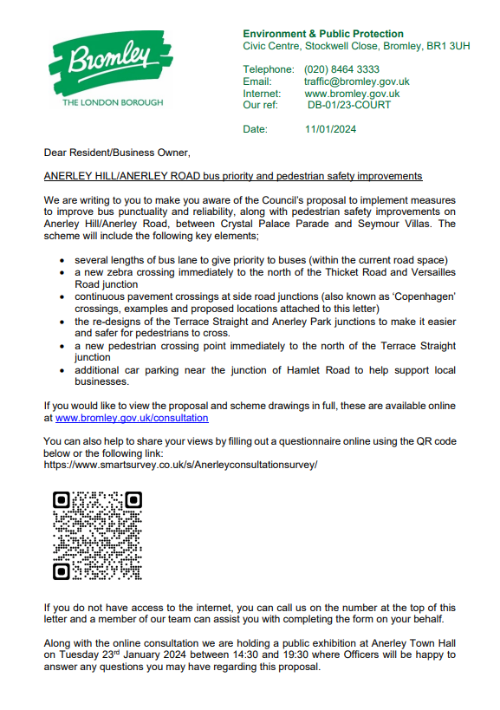
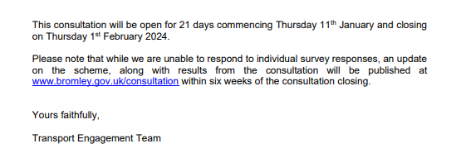
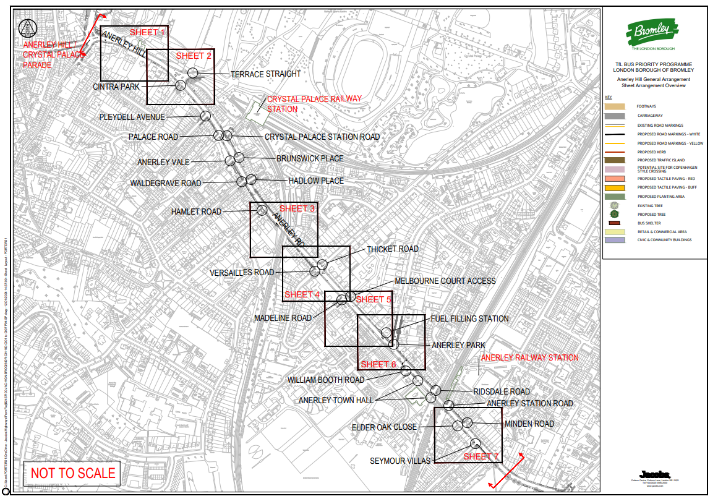

Appendix 2.1
Consultation Area (highlighted in yellow)
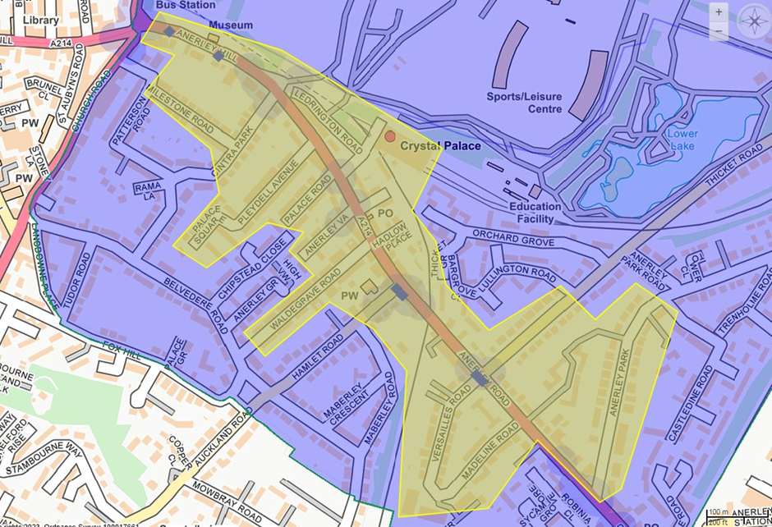
*The consultation area also included Patterson Road and Rama Lane as an extension request from Councillors
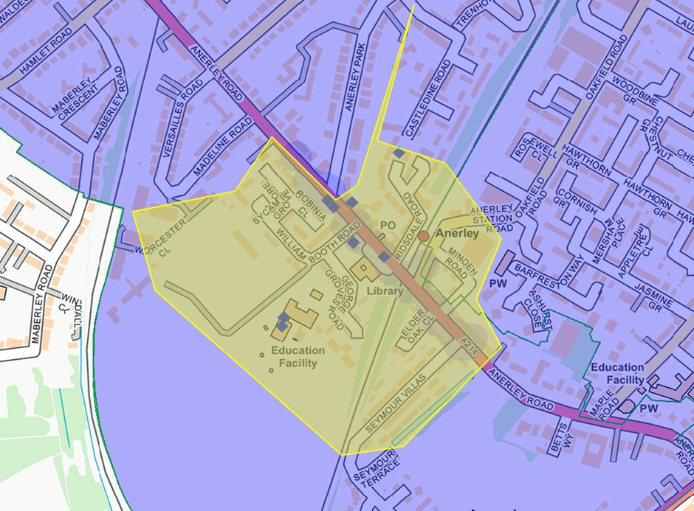

Appendix 2.2
Consultation Area
Anerley Hill (all shops and properties up to 33)
Anerley Station
Anerley Station Road (all properties up to Minden Road)
Anerley Road – (all properties and businesses from the start to 183)
Anerley Park (up to first bend approx. 29)
Anerley Vale (all properties)
Apple Yard (all properties)
Brunswick Place (all properties)
Cintra Park (up number 32)
Crystal Palace Station Road – train station
Elder Oak Close (all properties)
George Grove Road (all properties)
Hadlow Place (all properties)
Hamlet Road (all properties up to junction of Maberley Road)
James Dixon Primary School
Ledrington Road (all properties)
Madeline Road (all properties)
Marshall Court (all properties)
Melbourne Court (all properties)
Milestone Road (all properties)
Minden Road (all properties)
Owen Walk (all properties)
Palace Road (all properties)
Palace Square (all properties)
Patterson Road (all properties)
Playdell Avenue (all properties)
Playdell Gardens (all properties)
Rama Lane (all properties)
Ridsdale Road (all properties)
Robinia Close (all properties)
Seymour Villas (up to 113)
Sycamore Grove (all properties)
Thicket Road (all properties up to Lullington Road)
Thicket Grove (block on Anerley Road)
Thicket Terrace (just offset Anerley Road)
Versailles Road (all properties)
Waldegrave Road (all properties)
William Booth Road (all properties)

Appendix 3
