Images taken at Churchfields Road RRC approach road 07:45am Monday 25th of August 2025 by Veolia site operative.

- View along Churchfields Road towards Beckenham Road 2. View along the RRC approach road.
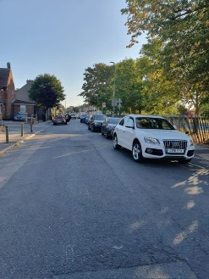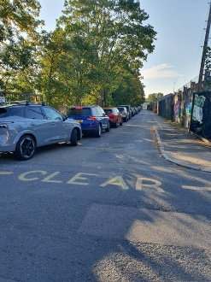

Prepared by Jim Cowan 26/08/25

