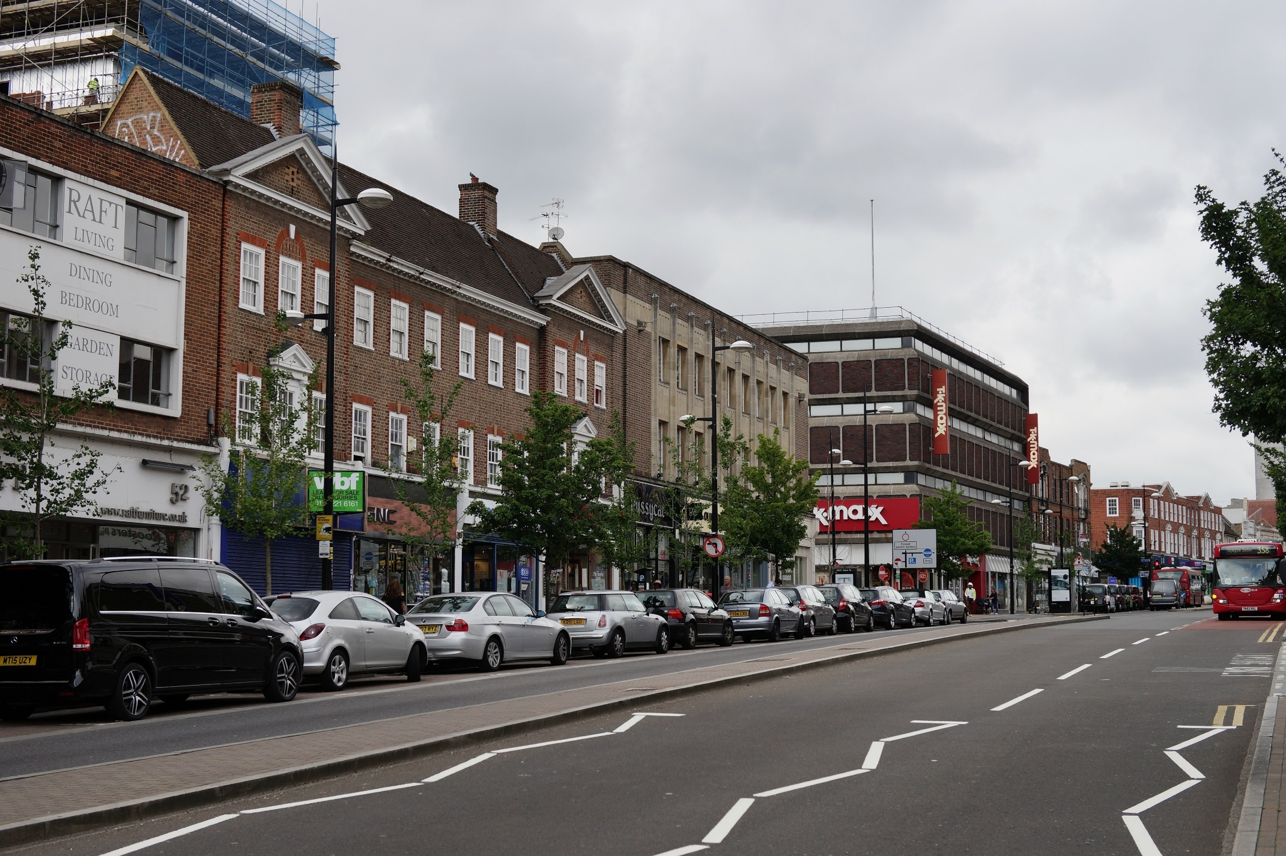

Highway Asset Management Plan
2025
Bromley Council


Version History
Version | Date | Description | Prepared by | Approved by
V1.0 | October 2025 | First Draft of HAMP | NA | EG
V2.0 | October 2025 | Second Draft of HAMP | NA | EG
Table of Contents
Foreword 5
The Borough 6
Introduction 7
Borough Context 8
Asset Management Framework 9
Strategies & Activities 11
Performance Management 12
Stakeholder Engagement 13
Service Delivery 15
Data-Driven Approach 16
Asset Knowledge 17
Network Hierarchy 18
Funding & Investment 19
Maintenance Strategies 20
Designing for maintenance 25
Climate & Resilience 26
Environmental Sustainability 27
Resilience & Emergencies 28
Improving the Service 31
Benchmarking with Other Authorities 32
Improvement Plan 32

Acronyms
Table 1: List of Acronyms
Acronym | Definition
ALARM | Annual Local Authority Road Maintenance
AMMA | Asset Management Maturity Assessment
AQMA | Air Quality Monitoring Area
BCI_{AV} | Bridge Condition Index Average Value
BCI_{CR} | Bridge Condition Index Critical Rating
BPRN | Borough-maintained Principal Road Network
DfT | Departement for Transport
FPNs | Fixed Penalty Notices
KPIs | Key Performance Indicators
LFRMS | Local Flood Risk Management System
LLFA | Lead Local Flood Authority
LoBEG | London Bridge Engineering Group
LoDEG | London Drainage Engineering Group
LoHEG | London Highways Engineering Group
LoTAG | London Technical Advisory Group
MMP | Maintenance Management Plan
NH | National Highways
NWSRG | National Winter Service Research Group
OLHAMC | Outer London Highway Asset Management Consortium
SuDS | Sustainable Urban Drainage Systems
TBC | To Be Confirmed
TfL | Transport for London
WSP | Winter Service Plan
WSPG | Winter Service Practitioners Group

Figures and Tables
Figure 1: Highway assets 7
Figure 2: Key features in Bromley 9
Figure 3: Highway Asset Management Framework 10
Figure 4: Strategies and Activities 11
Figure 5: Internal and External Stakeholders 14
Figure 6: Communication methods with external stakeholders 14
Figure 7: Bromley's highway maintenance funding levels 19
Figure 8: Types of civil and weather emergencies 28

Table 1: List of Acronyms iii
Table 2: KPIs related to Highways Asset Management Actions 12
Table 3: Service providers and responsibilities 15
Table 4: Bromley's Highway Asset Inventory 17
Table 5: Maintenance activities 20
Table 6: Improvement Action Plan 32

Foreword
The Council’s highway network is incredibly important, with both our roads and footways being used by residents on a daily basis. As London’s largest borough, with more than 550 miles of road, the distance from Bromley to Zurich and over 850 miles of footways, maintaining this asset is a considerable challenge.

One of our priorities in this is ensuring safe and healthy roads for all whilst at the same time not creating congestion and impeding freedom of movement and trade. Bromley has a good road safety record and reducing casualties remains central to Bromley’s transport priorities.

Our highways programme includes both reactive maintenance and planned replacement of worn road and footpath surfaces in the most efficient manner, utilising latest technology, where applicable and to guide prioritisation of planned work. We are committed to continuing with this important work, with funding critical to the success of this work as well.

Councillor Nicholas Bennett JP
Executive Member for Transport, Highways and Road Safety

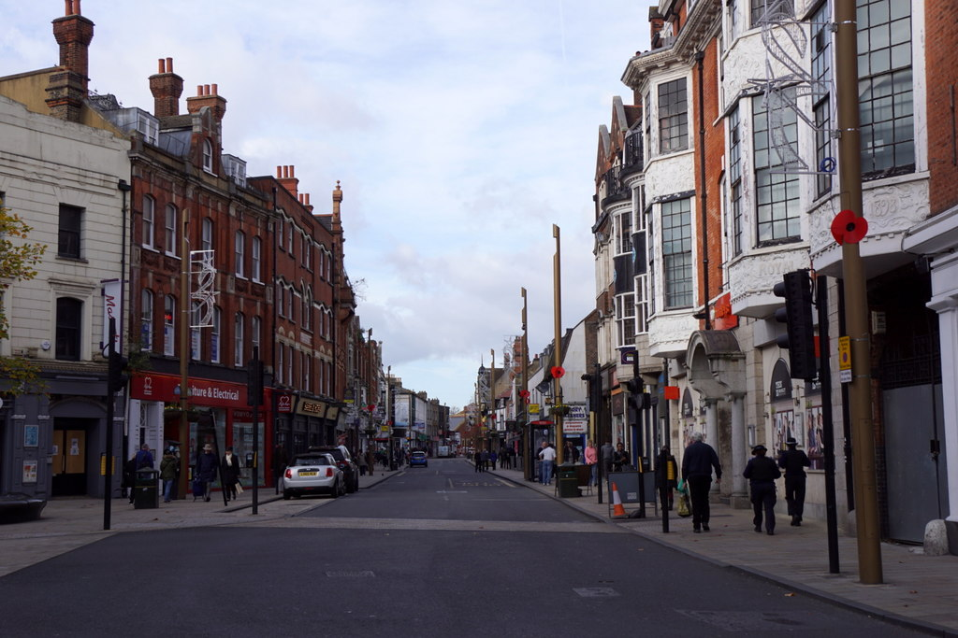
The Borough

Introduction




Bromley Council (Bromley) is responsible for managing 887 km of highway network and the associated assets outlined in Figure 1, including roads (carriageways), pavements (footways), structures (including bridges), street lighting, street furniture, drainage, and trees. This highway network plays a vital role in enabling the free movement of people and goods, as well as ensuring that essential services like schools, hospitals, and emergency services remain accessible to the public.
Carriageways | Footways | Cycleways | Structures




Street Lighting | Street Furniture | Drainage | Trees
Figure 1: Highway assets
As the Local Highway Authority, Bromley has a statutory duty under the Highways Act (1980) to ensure that “the highway network is accessible and maintained to a safe and serviceable condition, minimising risk to users and safeguarding the connections that support jobs, businesses and communities”. To meet its duties, Bromley adopts a risk-based, sustainable and needs-driven approach to managing its assets.

What is highway asset management?
Asset management is defined as “coordinated activities of an organization to realise value from assets” according to ISO 55000 ‘Asset Management’. It is a best practice approach to manage public assets, ensuring value for money and long-term sustainability.
To support the implementation of an asset management approach, Bromley has defined a strategic vision to realising value through its highway infrastructure in Strategies & Activities. This ensures that the Council implements risk-based, data-driven maintenance strategies that support outcomes and objectives set out in the different Council plans, comply with legislation and deliver value for money.

What is sustainable asset management?
The United Nations defines “three components of sustainable development – economic development, social development and environmental protection – as interdependent and mutually reinforcing pillars.” (United Nations World Summit Outcome Document, 2005). In the context of highways asset management, this means ensuring that investment and maintenance decisions not only deliver value for money and support economic activity, but also promote social equity, safety, and accessibility, while safeguarding the environment through responsible use of materials, energy, and land.

What is the purpose of this document?
This Highway Asset Management Plan (HAMP) outlines Bromley’s strategic approach to managing its highway assets in accordance with legislation, the Council’s strategic objectives and industry best practice and the UN’s sustainable development goals. The HAMP aims to support Bromley to:
- Comply with legislation and regulations
- Support national and regional plans and priorities
- Align highway maintenance activities with wider Council outcomes and objectives
- Deliver a risk-based, data-driven approach that ensures value for money
- Make long-term asset investment decisions that ensure a sustainable and resilient future
- Improve the environmental sustainability of highways assets and operations
This strategic plan outlines the Council’s commitment to improving the Highway Service and ensuring that Bromley is “a fantastic place to live and work, where everyone can lead healthy, safe and independent lives”. (Make Bromley Even Better (Corporate Strategy) 2021 – 2031).
The scope of the HAMP covers all streets in Bromley defined as highways maintained at the public expense under the Highways Act. Roads maintained by Transport for London (TfL), National Highways (NH) or private roads (including those maintained by other Bromley teams) are not within this scope.

Borough Context
Located in outer London, Bromley is London’s largest borough by land area with over half of the borough designated as open countryside, much of it within Metropolitan Green Belt land (Corporate Strategy 2021 – 2031). As a result, Bromley has the lowest population density of any borough, giving it a unique and rural character.
Compared with inner London, Bromley experiences higher levels of car ownership and lower public transport provision (Healthy Streets Scorecard 2025), resulting in an increased reliance on its highway network to support accessibility, economic activity, and connectivity across dispersed communities. This context places a particular emphasis on maintaining carriageways and associated assets to a standard that supports safe, reliable movement while retaining the distinct rural, suburban, and urban character areas within Bromley.
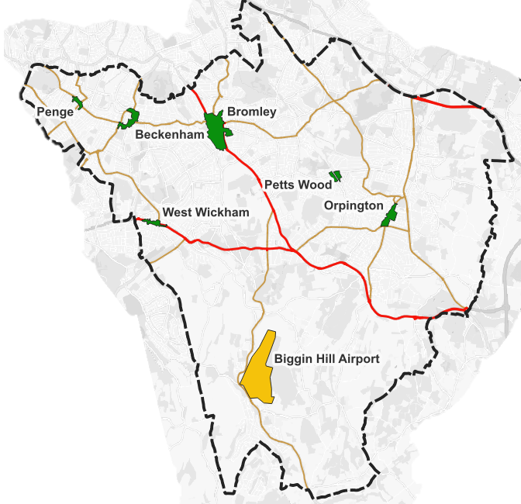
Figure 2 shows key features in Bromley. The town centres generate the most traffic within the borough, while the TfL red routes carry traffic through Bromley, towards the South East of England and the M25. Biggin Hill Airport also plays a significant role in generating local traffic, particularly due to its position as a key business aviation hub within the borough. The area surrounding the airport has seen targeted development in recent years, with the creation of an aviation-focused business park and supporting infrastructure, further contributing to increased vehicle movements and economic activity in this part of Bromley.
Town Centres
Biggin Hill Airport
TfL Road Network
Bromley A Roads
Bromley shares boundaries with the London Boroughs of Bexley, Lewisham, Southwark, Lambeth and Croydon, the Royal Borough of Greenwich and the County of Kent. This requires the Council to coordinate with different stakeholders to ensure consistency and continuity in the service delivery across different authorities.
Figure 2: Key features in Bromley

Asset Management Framework
The Asset Management Framework (the Framework) provides a common reference point for all internal and external stakeholders who are directly involved or have an interest in highway management and maintenance. It covers all aspects of the asset management service from strategic to operational levels, establishing high-level drivers for maintaining assets, while linking corporate aims to operations.

How is the Asset Management Framework formed?
The Framework in Figure 3 shows how Bromley Council’s highway activities link together to provide visibility and clarity of the key drivers behind our transport objectives and statutory duty to maintain a safe, serviceable, and sustainable highway network.
The Council’s Asset Management Framework is governed by five key groups. They are:
- Legislation: Laws and regulations which define the statutory duties that Bromley must legally comply with as well as the powers granted to it for enforcement.
- Guidance Documents: Nationally recognised guidance which sets out best practice methods to support consistent, effective and informed decision making for highway asset management
- National & Regional Policy: Objectives and priorities set at national and regional levels to inform the Council’s own strategies and plans
- Bromley Strategy & Plans: Policies which outline the key priorities for future development across Bromley including the Council’s values, strategic objectives and sustainability goals.
- Highway Asset Management: Risk-based, effective approach that Bromley follows to maintain its public highway assets.
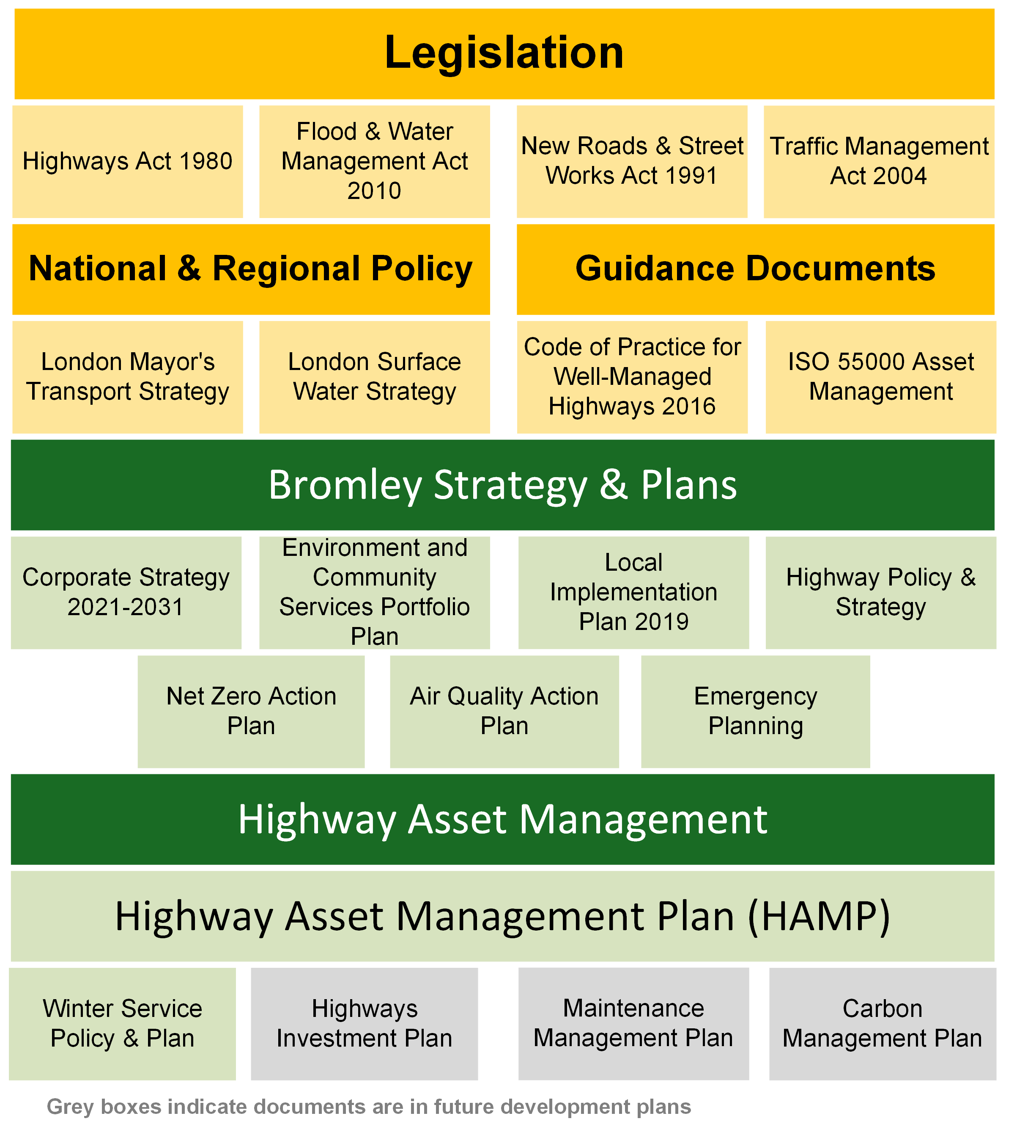
Figure 3: Highway Asset Management Framework

Strategies & Activities
Bromley aim to manage a highway network that provides safe, reliable connections for users of all transport modes and contributes towards the Council’s sustainability and development goals. As outlined in the strategy in Figure 4, key ambitions, visions and Highway Asset Management Actions have been drawn from the Corporate Strategy and the Environment and Community Services Portfolio Plan (Portfolio Plan) to support the delivery of desired outcomes. Those actions also support the outcomes outlined in Bromley’s Local Implementation Plan to achieve a safe, efficient and accessible transport network that supports the needs of the borough’s, and London’s, growing population.
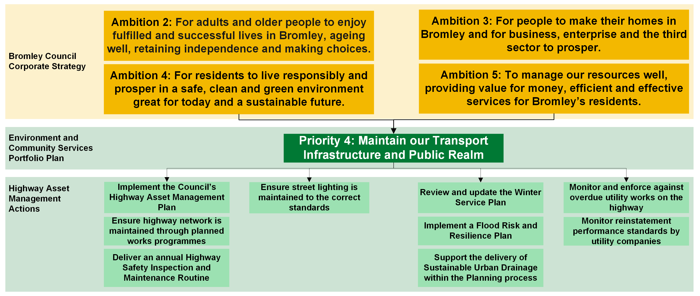
Figure 4: Strategies and Activities

Performance Management
Performance monitoring and management is important to ensure the required level of service is maintained. Bromley have developed a set of Key Performance Indicators (KPIs) (Table 2) derived from the Highways Asset Management Actions set in the Portfolio Plan (Figure 4) to track progress against specific progress and measure overall success of the service. These indicators inform long-term strategies such as investment planning, to understand the levels of funding needed to reach the intended level of service. They are essential in decision-making processes relating to prioritising interventions, tracking service performance and determining the effectiveness of maintenance processes and activities.
Table 2: KPIs related to Highways Asset Management Actions
Key Performance Indicators | 2025/26 | Target
Action 1: Implement the Council’s Highway Asset Management Plan
Condition of principal (A) roads (% considered for maintenance) | 2.31% | TBC
Condition of non-principal classified B & C roads (% considered for maintenance) | 27.9% | TBC
Condition of unclassified roads (% considered for maintenance) | 34.0% | TBC
Bridge Condition Score BCI_{AV} | 86 | 80-90%
Bridge Condition Score BCI_{CR} | 67 | 65-80%
Action 2: Ensure highway network is maintained through planned works programmes
Undertake boroughwide condition survey to assess impact of recent capital project | 100% | TBC
Completion of planned capital carriageway and footway maintenance projects (% complete) | 100% | TBC
Action 3: Deliver an annual Highway Safety Inspection and Maintenance Routine
Highway safety inspections completed on time (%) | 100% | 100%
Highway maintenance tasks completed within required timescale (%) | 84% | 90%
Action 4: Ensure street lighting is maintained to the correct standards
Routine street lighting maintenance tasks completed within four working days (%) | 98% | 95%
Routine street lighting maintenance tasks completed within eight working days (monthly) (%) | 99% | 100%
Action 5: Review and update the Winter Service Plan
Updated winter service policy & plan produced (Y/N) | Y | 2025
Action 6: Monitor and enforce against overdue utility works on the highway
Number of Fixed Penalty Notices (FPNs) issued (outcome) | 83 | NA
Action 7: Monitor reinstatement performance standards by utility companies
Number of Defect Notices (outcome) | 483 | NA
Action 8: Implement a Flood Risk and Resilience Plan
Flood Plan implemented (Y/N) | In progress | TBC
Action 9: Support the delivery of Sustainable Urban Drainage within the Planning process
Planning applications processed within required timescale (%) | 95% | 95%

Stakeholder Engagement
Stakeholder engagement is the process of coordinating with key groups or individuals to inform the decision-making process. In line with the Council Corporate Strategy’s ambitions to allow residents to “live responsibly and prosper in a safe, clean and green environment”, consideration of community needs is essential to ensure the social and economic benefits of highway investment are recognised. Robust communication channels are important to facilitate this by providing the opportunity to consider input from residents and businesses. Highway officers also engage with other key stakeholders before making decisions. This ensures that services are delivered effectively and efficiently, maintenance works cause minimal disruption and provide value for money, considering engineering and technical need.

Who are the stakeholders?
Stakeholders include third-parties who are directly involved in highway decisions (e.g. utility companies, neighbouring authorities, TfL, NH), highway users who rely on the network for transport and businesses which need resilient infrastructure to support economic activity. Figure 5 details the internal and external stakeholders involved in highway asset management:









Internal Stakeholders
Procurement Team
Finance Team
Legal Team
Emergency Planning
Elected Members
Highways
Network Management
Design & Delivery
Development Control
Comms Team




External Stakeholders
Educational Institutions
Property Developers
Emergency Services
Disabled Groups
Residents & Visitors
Local Business
Community Groups
Neighbour Authorities
Vulnerable Users
Figure 5: Internal and External Stakeholders

How are external stakeholders engaged with?



It is essential for external stakeholders to have accessible two-way communication forms. Residents and visitors can report defects on the highway network on the Council website. The reports are then inspected by Highway Officers and scheduled for repairs if they meet the required thresholds. Residents and businesses are informed about road works occurring on their street through letter drops, or the roadworks webpage for an overview of works planned across the borough. For any other enquiries, the main point of contact for residents and businesses are elected councillors. The methods of communication with external stakeholders are outlined in Figure 6:
Figure 6: Communication methods with external stakeholders
Public meetings

Public meetings
Council website

Council website
Leaflets & mail

How do we coordinate internally?
Engagement with internal stakeholders ensures effective collaboration between different council departments. The Highways Team liaises with the Network Management Team through regular meetings to notify upcoming works and gather information on utility works. Amendments to the works programme are made accordingly to prevent unnecessary damage to the network for any newly resurfaced roads. The coordination between different teams minimises disruptions to residents and businesses and streamlines maintenance activities on the streets.

Service Delivery
Bromley Council is committed to providing value for money as it delivers the highway asset management service, with support from external contractors and consultants to complement internal resources and ensure the works are carried out effectively and meet quality standards.
Bromley complies with all relevant legislation, including the Procurement Act 2023, to ensure that public tendering processes are conducted to maintain fair competition and uphold best practice. The Council liaises with its service providers regularly to increase collaboration and improve outcomes and has set in place a review process that provides a high level of auditability and transparency, with consideration of commercial confidentiality. Table 3 below shows the different service providers employed by Bromley.
Table 3: Service providers and responsibilities
Stakeholder |  | Services & Responsibilities
Highway Authority
Bromley Council | Highways Team | Highway management and asset maintenance
Bromley Council | Highway Trees | Highway trees inspections and maintenance
Bromley Council | Delivery | Public realm and traffic design and build
Transport for London |  | Operate public transport and maintain TfL Road Network, traffic signals, bus stops and speed cameras.
Term Maintenance Contractor
JB Riney & Company Ltd. |  | Planned carriageway and footway maintenance works
 |  | Reactive maintenance works
 |  | Gully inspection and cleansing
 |  | Winter service
 |  | Street lighting inspections, testing and maintenance works
Professional Services Consultants
Various Consultants |  | Some design, data collection and consultancy activities may be outsourced to specialist consultants.
Other Third-Parties |  | Statutory Undertakers, such as utility companies, and other third-party assets (e.g. cycle hire, EV chargers).

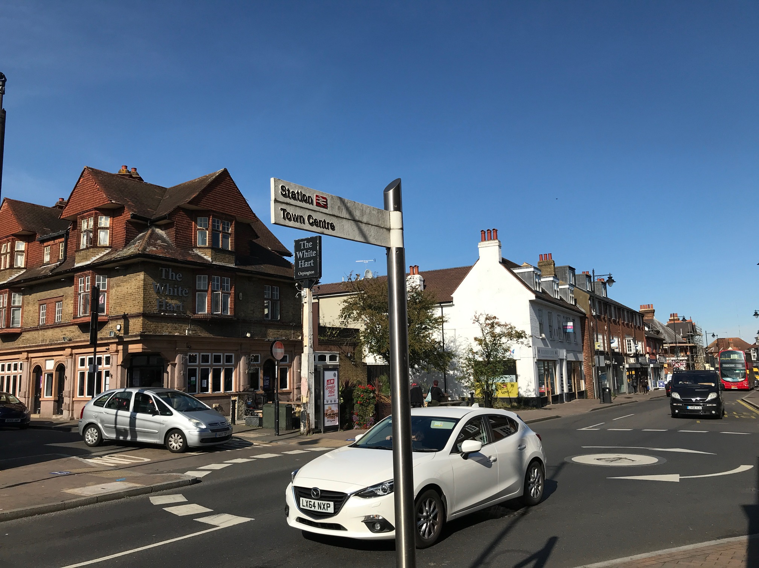
Data-Driven Approach

Asset Knowledge
To fulfil its statutory duties to maintain the public highway, Bromley Council aims to have a solid understanding of the size and performance of its highway asset base. This knowledge is key to making robust asset management decisions and supporting the effective delivery of maintenance activities. The types of information collected and stored for assets include:
- Geospatial location
- Physical attributes (dimensions, materials, age)
- Priority and risk factors (network hierarchy, classification)
- Condition, performance, inspection and testing results
- Planned, routine and reactive maintenance history

What does Bromley know about its highway network?
Bromley’s highway asset inventory is shown in Table 4 below.
Table 4: Bromley's Highway Asset Inventory
Asset Category | Asset Type | Quantity | System
Carriageways | Principal (A) | 70.2 km | Confirm
Carriageways | Non-principal (B,C & U) | 816.6 km | Confirm
Carriageways | Total | 886.8 km | Confirm
Footways | Prestige Areas (1A) and Primary Walking Routes (1) | 13.2 km | Confirm
Footways | Other Footways | 1,411.6 km | Confirm
Footways | Total | 1,424.8 km | Confirm
Cycleways | Total | 150.0 km | Confirm
Lighting | Total Lighting Columns | 27,561 | Confirm
Lighting | Feeder Pillars | 299 | Confirm
Lighting | Illuminated Bollards | 1,260 | Confirm
Lighting | Illuminated signs | 2,525 | Confirm
Lighting | Dedicated Electric Vehicle Charging Points | 21 | Confirm
Lighting | Wall Mounted Lights | 60 | Confirm
Lighting | Energy Use | 5,481,929.0 kWH | Confirm
Drainage | Gullies | 34,934 | Confirm
Drainage | Pipe Length | 105.0 km | Confirm
Street Furniture | Pedestrian Guard Rails | 5.0 km | Confirm
Street Furniture | Signs and bollards | 7,036 | Confirm
Street Furniture | Hostile Vehicle Mitigation Barriers | 5 | Confirm
Street Furniture | Vehicle Restraint Systems | 1 | Confirm
Structures | Road Bridges | 70 | BridgeStation
Structures | Footbridges | 26 | BridgeStation
Structures | Culverts | 109 | BridgeStation
Structures | Other Structures | 66 | BridgeStation
Trees | Trees | 36,000 | Confirm

Why is inventory and condition data collected?
Highway officers use Asset Knowledge to:
- Analyse and report on asset performance (condition surveys, testing and inspections)
- Monitoring the progress against Highway Asset Management Objectives (i.e. Performance Management)
- Understanding current and future investment needs (see Funding & Investment)
- Making cost-effective decisions and maximise value (see Funding & Investment)
It is therefore essential that data is managed to be accurate, up-to-date and complete. Highway officers, inspectors and term maintenance contractors are responsible for collecting data on highway assets and updating the asset inventory as and when things change.

Network Hierarchy
Bromley has defined a risk-based Network Hierarchy for its highway network that categorises every carriageway and footway by risk levels related to functionality and usage of the section. The Network Hierarchy is used across asset management activities to determine the frequency of safety inspections (monthly, quarterly, six-monthly or annually), provide weighting scores in prioritised work programmes and support investment planning exercises. The Network Hierarchy considers risk drivers such as:
- Roads with high traffic flows
- Town centres, retail and market areas
- Rail stations, bus and cycle routes
- Schools and colleges
- Hospitals, police, fire and ambulance stations

Funding & Investment
This section outlines the funding streams available to the Council and the investment needs to manage their highway network, addressing the economic sustainability of the Council. Investment into Bromley’s public highways is essential to maintain a safe, efficient, and well-managed network. Consistent funding that evolves to reflect inflation changes leads to better planning, and in result better value for money for the Council and the users.

What levels of funding are available for Bromley’s highway assets?
Bromley obtains capital and revenue funding from various sources:
- Capital funding is used to construct, maintain, replace or improve the assets on the highway network. It is funded from borrowing (TfL, Department for Transport – DfT), invest to save funds and developer contributions.
- Revenue expenditure is used for day-to-day operational costs to keep the network safe and serviceable, including reactive maintenance (e.g. pothole filling) and routine activities such as street light testing and highway safety inspections. It is funded from local taxes, fees and government grants.
Figure 7 shows Bromley Council’s past and current highway funding and sources.

Figure 7: Bromley's highway maintenance funding levels

Investment Strategy
Bromley Council will continually assess its future investment requirements by closely monitoring performance against KPIs and targets set in Performance Management. This proactive approach ensures that funding decisions are informed by up-to-date data, enabling the Council to respond effectively to emerging needs and maintain a high standard across the highway network.

Maintenance Strategies
Effective maintenance and investment strategies are critical for preventing the deterioration of highway assets and addressing defects efficiently. These strategies ensure that available resources are allocated where they deliver the greatest value. This section outlines Bromley’s approach to highway maintenance, supporting the objective of delivering a well-maintained network (Figure 4).

What maintenance activity types are used in Bromley?
Bromley council utilise a combination of maintenance activities to ensure that the network is safe and meets the needs of the public. The type of activities delivered within Bromley’s highway service is detailed in Table 5.
- Planned: Planned works to extend an asset’s life, renew or replace the asset.
- Reactive: Unplanned works to tackle safety issues and emergencies identified via inspections or reports
- Routine: Regular, scheduled work to maintain assets in a safe and serviceable state.
Table 5: Maintenance activities
Maintenance Type | Team
Planned Maintenance
Carriageway Resurfacing | Highways
Footway Reconstruction & Repaving | Highways
Lighting Column Replacements | Street Lighting
Drainage Renewals | Drainage
Structures Repairs & Renewals | Structures
Planned Tree Maintenance | Trees
Reactive Maintenance
Safety Defect Repairs | Highways
Street Furniture Repairs | Highways
Winter Gritting | Highways
Gully Blockages | Drainage
Street Lighting Faults | Street Lighting
Routine Maintenance
Highway Safety Inspection | Highways
Gully Cleansing Regime | Drainage
Street Lighting Inspections | Street Lighting
Structural Inspections | Structures
Tree Inspections | Trees
These maintenance activities are carried out following a risk-based approach to prioritise safety and accessibility. An operational maintenance management plan (MMP) is being developed to provide detailed maintenance regimes for each asset category. The following sections give a brief overview of the maintenance strategies:

Works Prioritisation
Bromley uses a data-driven approach to create a forward annual maintenance programme and ensure efficient use of public resources. Developing a programme provides a greater transparency of works and allows for more collaboration between different highway related works to streamline operations and reduce disruption. For residents and businesses, the programme provides an understanding of the type and location of planned works. Risk-based factors are used to prioritise assets. These factors include:
- Asset condition or level of service
- Safety criticality, functionality and usage
- Local community and business benefits
- Local knowledge/engineering judgement
Consideration of the above factors ensures that investment is allocated towards assets that provide the most social and economic benefits while ensuring the highway network remains safe and serviceable.
Bromley will continue to find opportunities to combine maintenance activities by liaising with internal and external stakeholders.

Carriageways and Footways
Each year, Bromley undertakes comprehensive carriageway condition surveys across all roads in the borough, utilising artificial intelligence (AI) systems to efficiently and objectively assess the condition of the roads and identify defects. In addition, the Borough-maintained Principal Road Network (BPRN) is surveyed annually by Transport for London (TfL) and the London Highways Engineer Group (LoHEG) as part of a wider pan-London programme, employing the same intelligence-based technology.
Footways are assessed through engineering walked surveys. The collected condition data, alongside key priority factors, informs the development of forward works programmes, ensuring a coordinated and strategic approach to maintenance. Planned activities in Bromley consist of resurfacing, surface dressing, footway reconstruction or relaying.
While Bromley aim to prioritise planned maintenance to maximise wider benefits and provide value for money, regular safety inspections are also undertaken to capture safety critical defects. The Network Hierarchy determines the frequency of inspections, depending on the risk associated with the section. The defects are raised as reactive jobs to be completed within a timeframe aligned with the safety inspections risk assessment to ensure the network remains safe and serviceable.
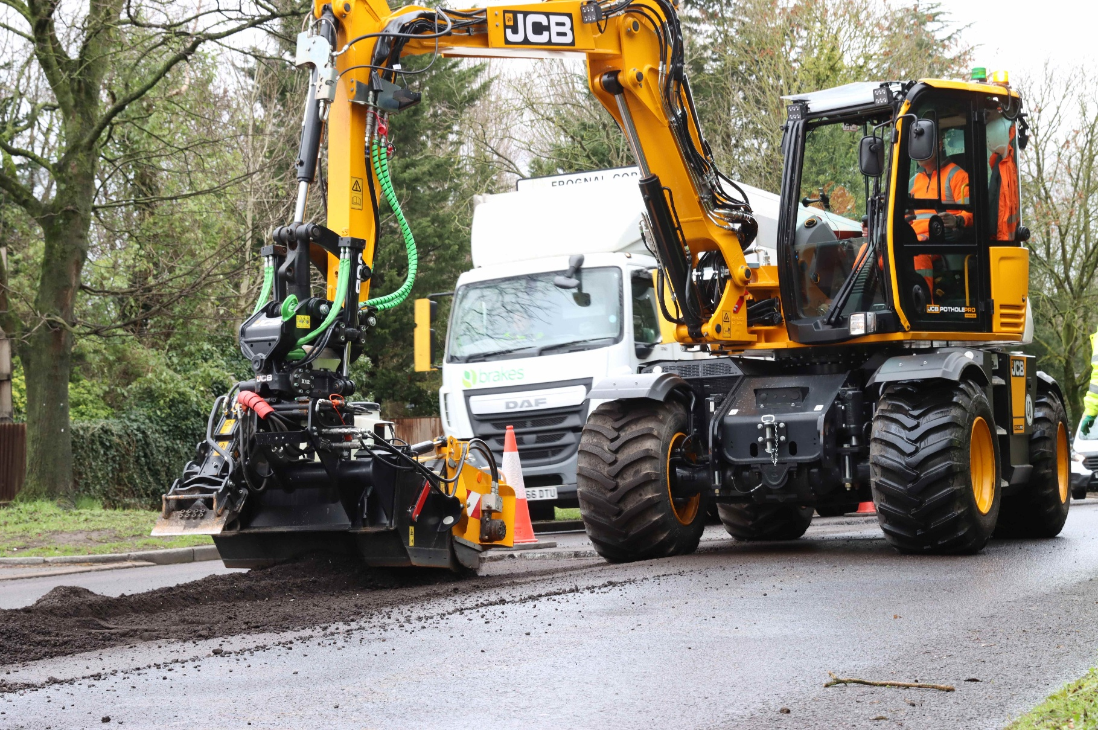
Carriageway maintenance in operation

Structures
Bromley manages structure asset information using BridgeStation, a tailored London Bridge Engineering Group (LoBEG) system. The system links inspection records and condition scores to each asset, enabling the creation of a prioritised maintenance list which guides Bromley in undertaking planned structural or non-structural works:
- Structural repairs: ensure integrity and load-bearing capacity of the structure, such as repairs to abutments, joints, bearings, parapets and walls
- Non-structural repairs: ensure serviceability, such as renewal of mechanical, electrical or lighting equipment, repainting or corrosion protection
By carrying out routine inspections and planned works, Bromley aim to reduce reactive works needed on the structures to avoid major disruptions and prevent incidents. The need for reactive maintenance is dependent on the asset’s safety risk, and the timeline for undertaking repair works is determined by the severity of the faults or defects.

Drainage
Bromley routinely clean gullies in the borough to ensure they are operating at optimum level. The cleansing frequency is determined by the relative risk of gully to the drainage and highway network. The risk-based approach considers the following:
- Risk of Flooding
- Road Hierarchy
- Historic Flooding
- Tree Coverage
Bromley aim to minimise reactive works on drainage assets by developing maintenance programmes that target identified defects and prevent flooding events. Planned maintenance consists of renewal or replacement of gully pots, grates and frames, pipes, carrier drains and manholes. When urgent defects are flagged, or surface water flooding is reported, Bromley will act within 24 hours to repair the damage caused to its assets and eliminate the likelihood of the event occurring.
In line with targets set in Performance Management, Bromley aim to introduce Sustainable Drainage Systems (SuDS) where feasible. Bromley routinely maintain rain gardens and green spaces to ensure they are adequately reducing the risk of flooding.

Street Furniture
Street Furniture assets, such as bollards, guardrails and cycle stands, are dealt with on a reactive basis and repaired if maintenance is identified through highway inspections.

Street Lighting
Bromley measures performance of street lighting by undertaking regular tests and inspections on all units within the borough. The tests include:

- Electrical testing
- Structural testing of columns
- Non-structural testing
- Visual inspection
- Night scouting

The street lighting maintenance involves planned, routine and reactive regimes. Bromley prioritises planned and routine maintenance to extend the assets life and seeks to reduce reactive works by improving their asset knowledge and intervening promptly.

Highway Trees
The Trees Team regularly inspects street trees and undertakes maintenance to help minimise risks associated with this asset, including routine and ad hoc canopy maintenance and basal reduction.
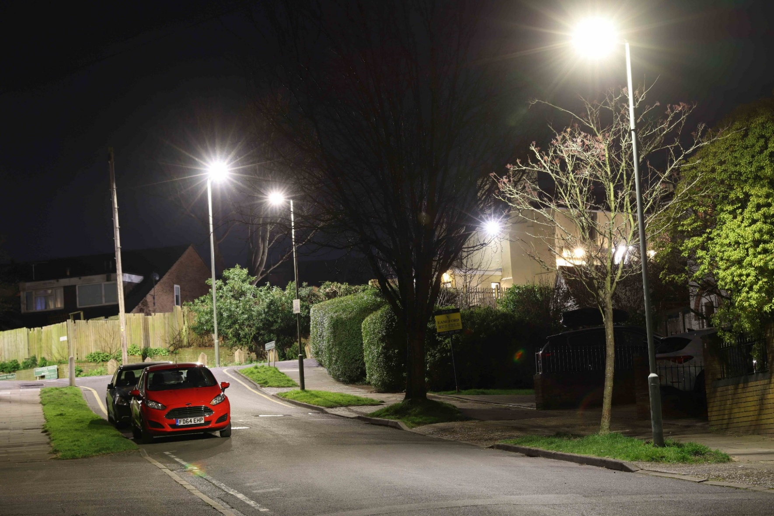
Street Lighting Asset in Bromley

Designing for maintenance
Designing for maintenance considers the risks and costs associated with highway maintenance over the asset lifecycle at an early stage of the decision-making process. It ensures a whole-life approach to asset management, and safeguards network resilience in the face of future challenges.

How are we designing for maintenance?
Bromley ensure maintenance strategies and investment plans promote whole-life value, as detailed in Funding & Investment and Maintenance Strategies. Key stakeholders such as maintenance contractors are involved during key design stages to highlight any issues that would hinder future maintenance requirements. Whole life carbon considerations is also be considered as part of designing for maintenance, as detailed in Environmental Sustainability to support Bromley’s objective aim to become a Net Zero Council by 2029.
To ensure that the whole-life value is realised through the asset maintenance service, Bromley are developing a Maintenance Management Plan (MMP) that captures Bromley’s best practice approach to maintaining assets through a whole-life approach. This will include a maintenance intervention matrix for each asset, with whole-life costings and embodied carbon.
Upon completion of schemes to maintain existing or construct new assets, highway officers will update the asset management systems to ensure appropriate long-term maintenance plans are put in place.

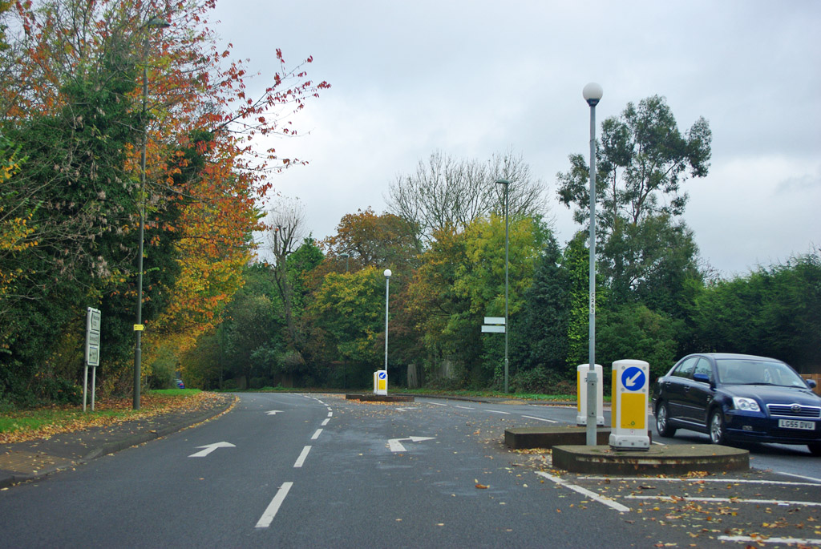
Climate & Resilience

Environmental Sustainability
This section focuses on the environmental pillar of Bromley’s sustainable maintenance approach. Bromley have made a commitment to achieve net-zero carbon as a Council by 2027, developing a Net Zero Action Plan to consolidate their objectives. The Council also pledged to reduce emissions within the borough, by achieving objectives outlined in the Air Quality Action Plan. The key pledges from the plans are:
- Encourage active travel (walking, cycling) and public transport use; and promote low-emission vehicles and anti-idling campaigns.
- Ensure new developments are air quality neutral and promote energy efficiency, including in council buildings.
- Work with schools and community groups to promote clean air initiatives and support vulnerable groups affected by poor air quality.
- Invest in alternative technologies and renewable energy projects and deliver targeted local projects.
- Review and expand air quality monitoring sites, including NO₂, PM₁₀, and PM₂.₅.

How do we address maintenance sustainability?
Bromley have set an ambition to maintain a clean and green environment in the borough (Figure 4) and have developed a process to ensure they achieve their objectives:
- Understand emissions: by setting up air quality monitoring areas (AQMAs), the council has a data-driven approach to pinpoint poor air quality hotspots.
- Identify correct reduction strategies: by understanding the locations and sources of emissions, the council will decide on the most appropriate reduction strategies going forward.
- Monitor and track progress: by expanding monitoring areas and tracking progress, Bromley can assess the success of the reduction strategies employed and try new processes if necessary.
Highway maintenance reduction strategies follow the carbon reduction hierarchy outlined in the PAS 2080 ‘Carbon Management in Infrastructure and Built Environment’ (2023) as the overarching principle to minimise emissions and adhere to corporate ambitions. The hierarchy focuses on the biggest emitters to minimise emissions from highway activities:
- Avoid: Employ a risk-based approach to focus maintenance efforts on where most needed or impact is greatest, reducing unnecessary emissions.
- Switch: Adopt lower-carbon materials, methods and technologies, such as warm mix asphalt and LED lighting, to reduce embodied carbon over the whole-life of an asset and at all stages.
- Improve: Identify improvement opportunities to reduce embodied carbon in all activities
To achieve the performance targets set in Table 2, Bromley has taken several steps to reduce its environmental impacts such as:
- Upgraded all street lighting to LED technology and adoption of trimming and dimming
- Maximised use of Warm-mix asphalt resurfacing
- Incorporated Sustainable Drainage Systems (SuDS) and green spaces when designing maintenance works where possible.
- Invested in Winter Service to reduce salt use.
Bromley are following up to date industry innovations to keep improving the air quality in the borough and achieve their corporate ambitions.

Resilience & Emergencies






Resilience refers to the ability of highway infrastructure to prevent, withstand, adapt and recover from adverse events and emergencies. As defined by the Civil Contingencies Act 2004, an emergency is an event or situation which threatens serious damage to human welfare, the environment or an act of war or terrorism that threatens serious damage to UK security. Network resilience is therefore crucial to prevent service level reductions following emergencies (Figure 8) ranging from chemical or criminal incidents to extreme weather events such as ice, snow, flooding and heat, as climate change increases both the frequency and severity of such events. Safeguarding network resilience is therefore an integral aspect of the asset management strategy that aims to maintain a safe public realm for a sustainable future.
Figure 8: Types of civil and weather emergencies
Extreme Weather
Structural Collapse
Rail & Road Incidents
Utility Incidents
Chemical & Pollution
Terrorist Incidents

Emergency Planning
Bromley Council’s Emergency Planning team has established a set of procedures to effectively manage incidents as they arise. It sets out how the Council will work with other Category 1 responders to plan for and respond to civil emergencies in accordance with its statutory duties under the Civil Contingencies Act 2004. Emergency plans for events more specifically impacting highway infrastructure also exist within the following documents:
- Local Flood Risk Management Strategy (LFRMS)
- Winter Service Plan (WSP)
The Highways team will cooperate with the Emergency Planning team to review and improve its approach to emergencies including planning, response and communication. It will document changes and improvements in operational plans which clearly detail the roles, responsibilities and processes in an emergency on public highways.

Resilient Network
Bromley is committed to providing resilience by recognising and protecting key links in the borough and preparing appropriate emergency plans. As a result, the Council has defined a Resilient Network that represents a group of strategic roads that are essential for the continuity of economic activity and access to essential and emergency services such as hospitals, fire and police stations, schools and shops. The network has been defined in coordination with other London boroughs through the London Technical Advisory Group (LoTAG). In the event of emergencies, resources will be prioritised towards the Resilient Network to ensure it recovers as quickly as possible and remain operational.

Winter Service
Bromley has developed a Winter Service Plan (WSP) which sets out the operational plans and policies for dealing with snow and ice on public highways. The Council’s policy is to provide a Winter Service, in line with Section 41A of the Highways Act 1980, that so far as reasonably practical, will allow for pre-defined routes of carriageways to be treated in accordance with their priority on the highway network and prevailing weather conditions so as to prevent the formation of ice and facilitate the removal of ice and snow from carriageways, footways and cycleways.
By determining this policy, it is the intention to minimise the risk to safety that highway users confront in winter conditions and minimise the non-availability of the highway network through ice and snow. Winter gritting routes are established using a risk-based approach, prioritising resource allocation towards the Resilient Network and other local roads carrying bus routes, high traffic flows or access to emergency services. This ensures a targeted and rational approach in line with the Code and the National Winter Service Research Group (NWSRG) guidance. However, this policy recognises that given the scale of financial and other resources involved in delivering the Winter Service, it is not practically possible to provide the service on all parts of the highway network, neither is it possible to satisfy the requirements of all those wishing to use the highway.
The Winter Service Plan also details the regular coordination with other London boroughs through participation in the LoTAG Winter Service Practitioners Group (WSPG).

Flooding
Bromley is designated as the Lead Local Flood Authority (LLFA) under the Flood and Water Management Act 2010. This means that Bromley, as part of the South East London Flood Risk Management Partnership (the Partnership), is responsible for managing local flood risk and coordinating with a wide range of stakeholders (e.g. Thames Water, Environment Agency, River & Canal Trust). The Partnership, formed with the London Boroughs of Bexley and Lewisham and the Royal Borough of Greenwich, ensures greater coordination and a common approach to achieve their aims and objectives. On a borough level, Bromley has developed a Local Flood Risk Management Strategy (LFRMS) that outlines the flood risk in the borough and the objectives put in place to manage it in collaboration with partners. Subsequently, the Action Plan lists the activities that would achieve the objectives and mitigate the flood risks, including incorporating SuDS schemes and maintaining drainage assets around flooding hotspots.

Risk Register
Bromley will review its Risk Registers and implement regular Risk Review meetings to monitor the strategic and operational risks and develop plans to mitigate them. This will ensure appropriate emergency communication plans are in place, with clearly defined stakeholders and roles and responsibilities, leading to a fast response and recovery in the event of an emergency impacting the public highways.
Winter gritting in operation
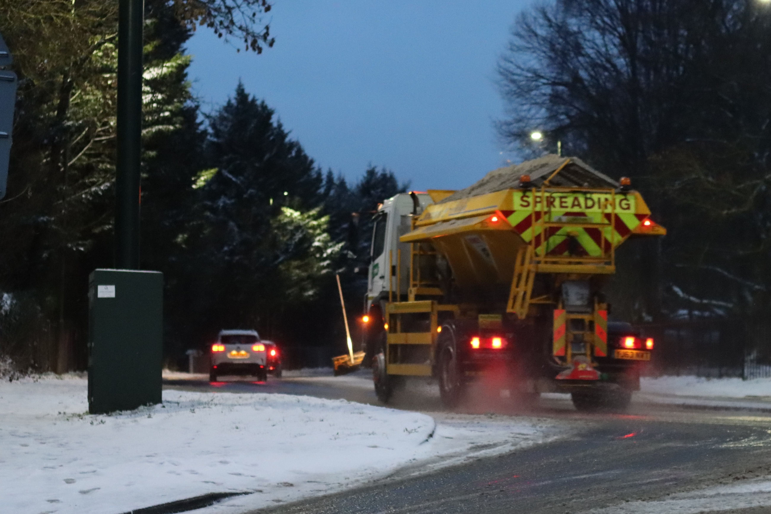

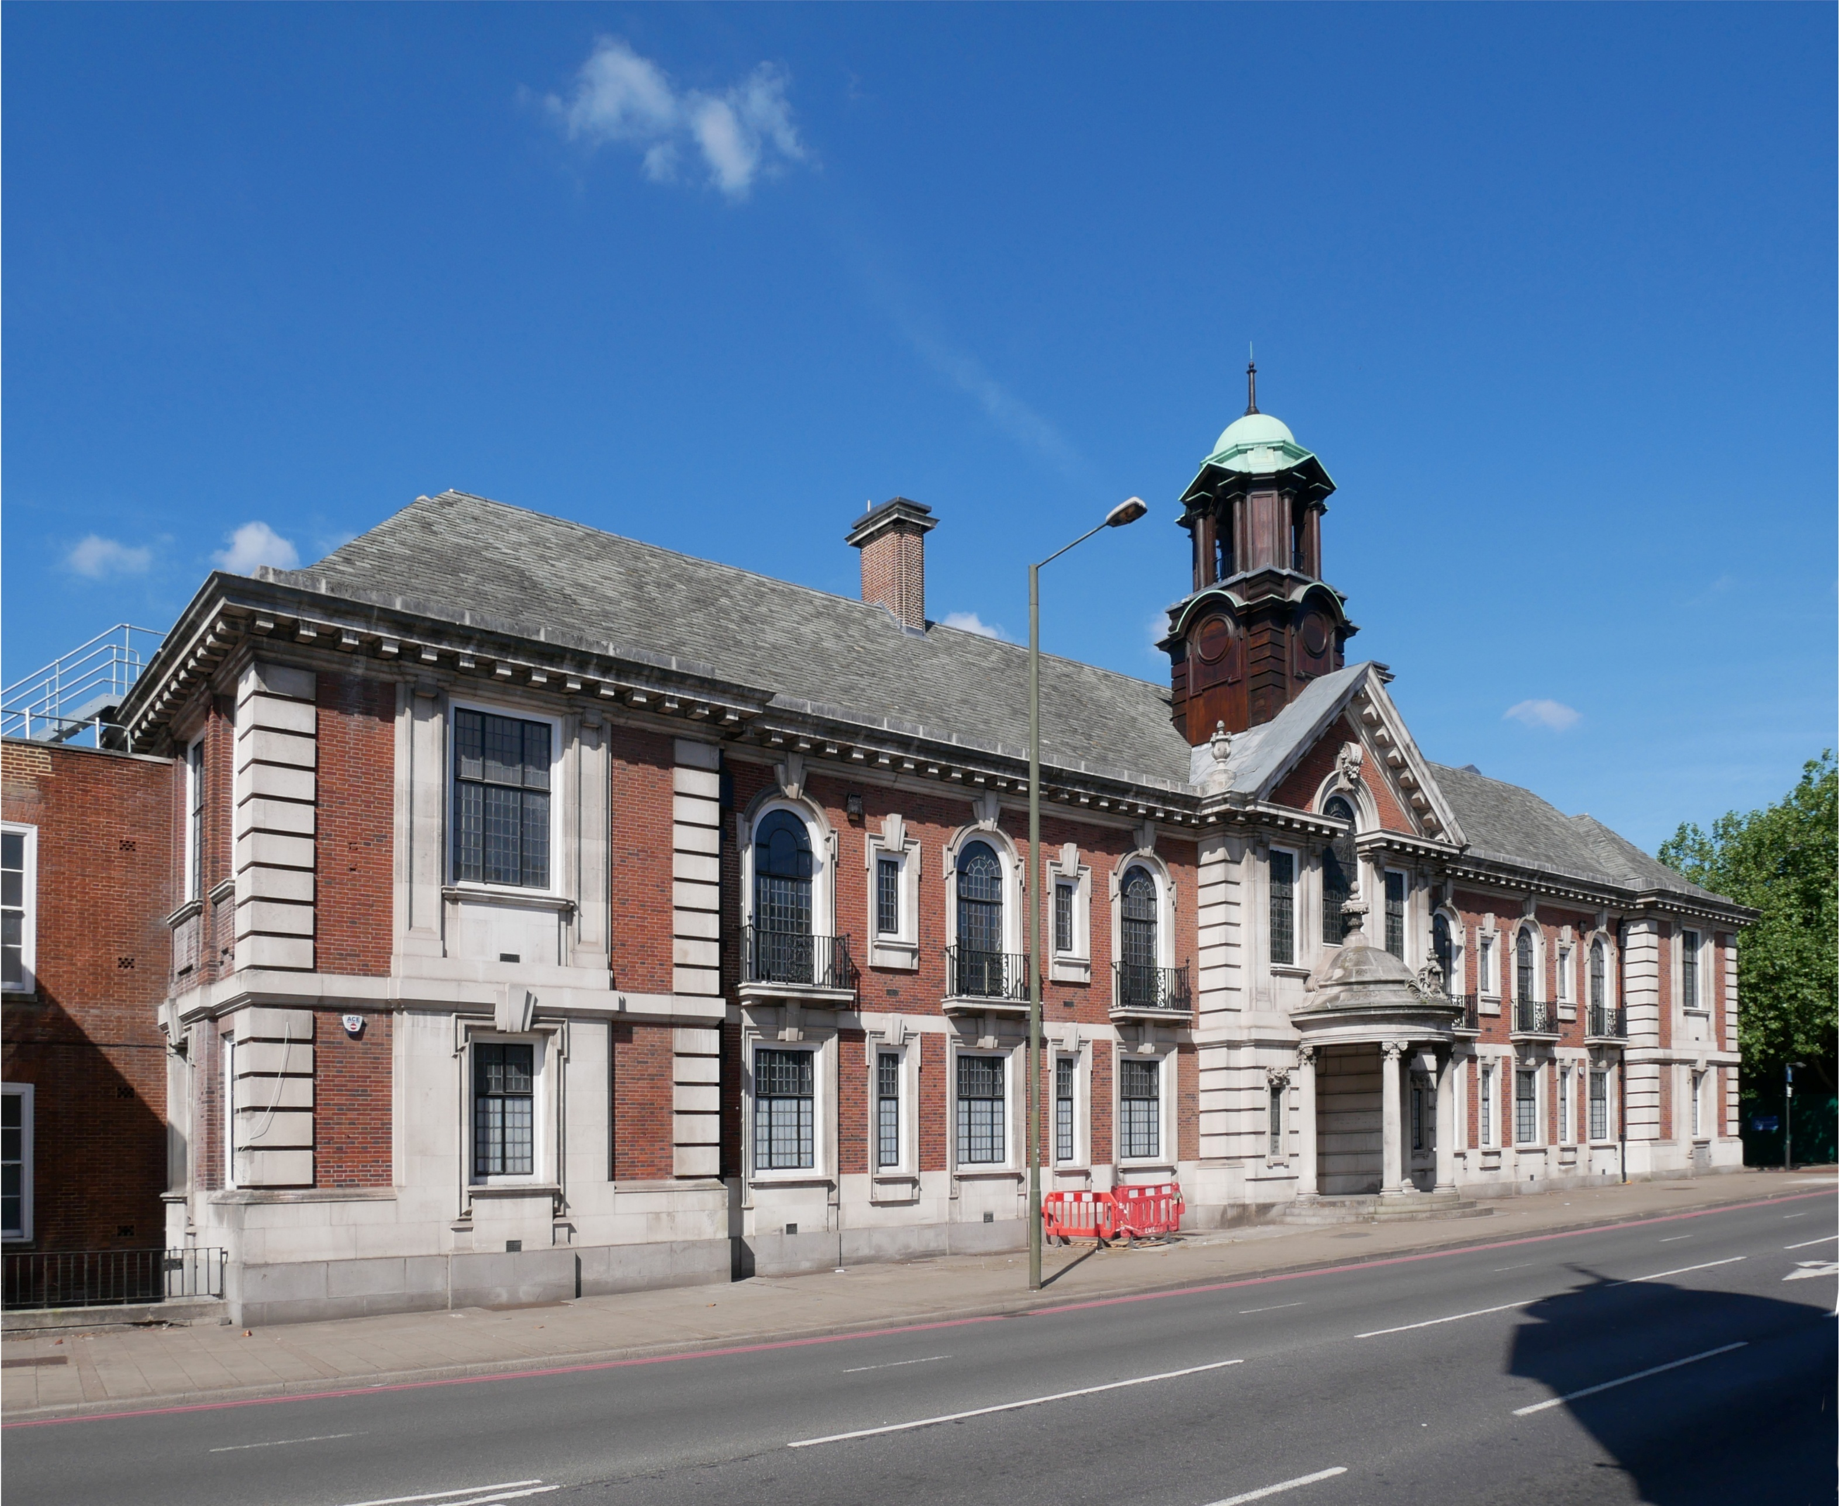
Improving the Service

Benchmarking with Other Authorities
As members of the Outer London Highway Asset Management Consortium (OLHAMC), Bromley contribute to the data collected and shared with the OLHAMC to assess the performance of each of its members councils. This process allows the councils to share information on new innovations and collaborate to deliver maintenance activities. Understanding how Bromley perform against other boroughs with similar context and pressures allows Bromley to evaluate its investment decisions and focus its policies. The OLHAMC gives the councils opportunities to compare approaches and share best-practice, helping build robust long-term asset management planning strategies and identifying practices that work well across London.
Bromley also participates in the Annual Local Authority Road Maintenance (ALARM) and DfT transparency surveys. This allows Bromley to share and compare performance with other councils nationally and identify opportunities to adopt best practice approaches. This information is valuable to Bromley’s stakeholders, as it allows them to better understand how the council is performing compared to other councils across the country, leading to greater transparency and accountability.

Improvement Plan
Continuous improvement is an essential element of asset management for Bromley, enabling financial savings and better decisions to be made. This HAMP is designed to define how the council operates and the key actions to improve.
Bromley undertakes continuous improvement according to ISO 55000 (Asset Management) and as outlined in the Code of Practice for Well-Managed Highways (2016). Bromley will periodically conduct an Asset Management Maturity Assessment (AMMA), a form of gap analysis, to highlight disparities between the current and desired asset management practices and identify areas for improvement. An Improvement Action Plan (Table 6) has been set out to outline improvements to be made. These actions will enable operational efficiencies, financial savings and enhanced decision-making.
Table 6: Improvement Action Plan
Action | Description | Section | Priority
Highway Investment Plan | A strategic document showing the current investment levels and the future funding needs based on deterioration models and KPIs set | Highways | Medium
Maintenance Management Plan | An operational document that details the planned, reactive and routine maintenance regimes of different highway assets | Highways | Medium
Carbon Management Plan | A strategic plan that outlines highway carbon baselining and reduction processes | Carbon Management and Greenspace Team | Medium

