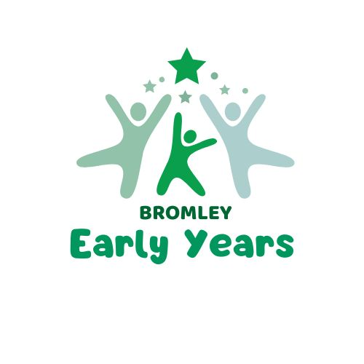
Childcare
Sufficiency
Ward Data

London Borough of Bromley

August 2025


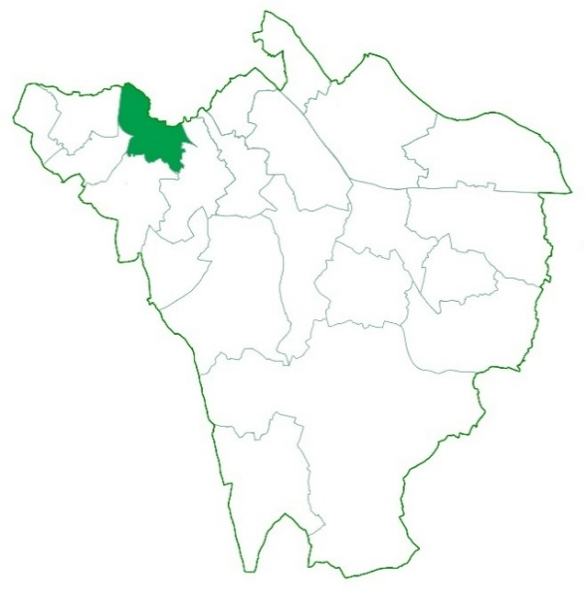
Beckenham Town & Copers Cope
 | Child population aged 0-2 years 2024-2025 | 566  (549 in 25-26)
 | Child population aged 3-4 years 2024-2025 | 337  (342 in 25-26)
 | Child population aged 5-14 years 2024-2025 | 1576  (1574 in 25-26) | Total child population for this ward is 2,482 for the academic year 2024-2025. With an estimated population for 2025-2026 of 2462 children, a slight decrease in population growth.
 | Childcare Places  In Preschools, Day Nurseries and Childminders | 478 | This ward has seen an increase in available 0-4-year-old childcare places since the last assessment. There are no academy nursery classes in this ward.
 | The total number of providers | Childminders 6 | Preschools  6 | Day Nurseries  4
Ratio | Ratio of childcare places to children | Population 0-4 years  903 | Registered places  478 | Childcare ratio  0.52
 | Quality  Outstanding, Good and Not yet Inspection | 100% | This is an area where the quality of childcare on offer to parents is high.

​  New homes being developed 2025 - 2028 | ​131
​  ​Is this a priority area for additional provision? | No

Bickley & Sundridge
 | Child population aged 0-2 years 2024-2025 | 541  (532 in 25-26) | 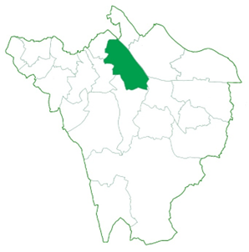
 | Child population aged 3-4 years 2024-2025 | 384  (376 in 25-26)
 | Child population aged 5-14 years 2024-2025 | 2216  (2190 in 25-26) | Total child population for this ward is 3,141 for the academic year 2024-2025. With an estimated population for 2025-2026 of 3098 children, a slight decrease in population growth.
 | Childcare Places  In Preschools, Day Nurseries and Childminders | 642 | This ward has seen an increase in available 0-4-year-old childcare places since the last assessment. There are no academy nursery classes in this ward.
 | The total number of providers | Childminders 11 | Preschools  7 | Day Nurseries  4
Ratio | Ratio of childcare places to children | Population 0-4 years  925 | Registered places  642 | Childcare ratio  0.69
 | Quality  Outstanding, Good and Not yet Inspection | 100% | This is an area where the quality of childcare on offer to parents is high.

​  New homes being developed 2025 - 2028 | ​80
​  ​Is this a priority area for additional provision? | No

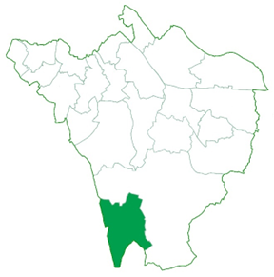
Biggin Hill
 | Child population aged 0-2 years 2024-2025 | 315  (310 in 25-26)
 | Child population aged 3-4 years 2024-2025 | 214  (219 in 25-26)
 | Child population aged 5-14 years 2024-2025 | 1273  (1266 in 25-26) | Total child population for this ward is 1,802 for the academic year 2024-2025. With an estimated population for 2025-2026 of 1795 children, a slight decrease in population growth.
 | Childcare Places  In Preschools, Day Nurseries and Childminders | 177 | This ward has seen a decrease in available 0-4-year-old childcare places since the last assessment due to local childminders closing.
 | The total number of providers | Childminders 6 | Preschools  6 | Day Nurseries  4
Ratio | Ratio of childcare places to children | Population 0-4 years  529 | Registered places  177 | Childcare ratio  0.33
 | Quality  Outstanding, Good and Not yet Inspection | 100% | This is an area where the quality of childcare on offer to parents is high.

​  New homes being developed 2025 - 2028 | ​21
​  ​Is this a priority area for additional provision? | Yes

Bromley Common & Holwood
 | Child population aged 0-2 years 2024-2025 | 658  (646 in 25-26) | 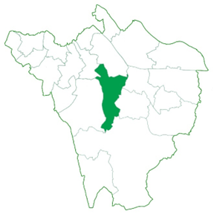
 | Child population aged 3-4 years 2024-2025 | 449  (441 in 25-26)
 | Child population aged 5-14 years 2024-2025 | 2513  (2459 in 25-26) | Total child population for this ward is 3,670 for the academic year 2024-2025. With an estimated population for 2025-2026 of 3,546 children, a slight decrease in population growth.
 | Childcare Places  In Preschools, Day Nurseries and Childminders | 730 | This ward has seen a decrease in available 0-4-year-old childcare places since the last assessment. Due to childminders closing.
 | The total number of providers | Childminders 27 | Preschools  10 | Day Nurseries  3
Ratio | Ratio of childcare places to children | Population 0-4 years  1107 | Registered places  730 | Childcare ratio  0.65
 | Quality  Outstanding, Good and Not yet Inspection | 98% | This is an area where the quality of childcare on offer to parents is high.

​  New homes being developed 2025 - 2028 | ​68
​  ​Is this a priority area for additional provision? | No

Bromley Town
 | Child population aged 0-2 years 2024-2025 | 524  (532 in 25-26)
 | Child population aged 3-4 years 2024-2025 | 371  (356 in 25-26) | 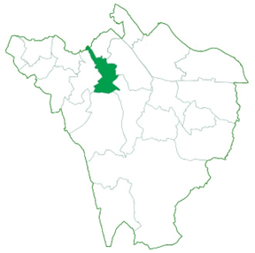
 | Child population aged 5-14 years 2024-2025 | 1822  (1812 in 25-26) | Total child population for this ward is 2,717 for the academic year 2024-2025. With an estimated population for 2025-2026 of 2,700 children, a slight decrease in population growth.
 | Childcare Places  In Preschools, Day Nurseries and Childminders | 699 | This ward has seen an increase in available 0-4-year-old childcare places since the last assessment. With the increase of new provision. There may be a sufficiency impact if all new homes are built.
 | The total number of providers | Childminders 12 | Preschools  4 | Day Nurseries  8
Ratio | Ratio of childcare places to children | Population 0-4 years  895 | Registered places  699 | Childcare ratio  0.78
 | Quality  Outstanding, Good and Not yet Inspection | 100% | This is an area where the quality of childcare on offer to parents is high.

​  New homes being developed 2025 - 2028 | ​587
​  ​Is this a priority area for additional provision? | Not Yet

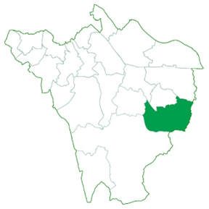
Chelsfield
 | Child population aged 0-2 years 2024-2025 | 315  (310 in 25-26)
 | Child population aged 3-4 years 2024-2025 | 238  (242 in 25-26)
 | Child population aged 5-14 years 2024-2025 | 1529  (1504 in 25-26) | Total child population for this ward is 2,082 for the academic year 2024-2025. With an estimated population for 2025-2026 of 2,056 children, a slight increase in population growth.
 | Childcare Places  In Preschools, Day Nurseries and Childminders | 549 | This ward has seen an increase in available 0-4-year-old childcare places since the last assessment. Including one new school-based nursery opening September 2025.
 | The total number of providers | Childminders 16 | Preschools  4 | Day Nurseries  3
Ratio | Ratio of childcare places to children | Population 0-4 years  553 | Registered places  549 | Childcare ratio  0.99
 | Quality  Outstanding, Good and Not yet Inspection | 91% | This is an area where the quality of childcare on offer to parents is high, just two providers who Require Improvement.

​  New homes being developed 2025 - 2028 | ​22
​  ​Is this a priority area for additional provision? | No

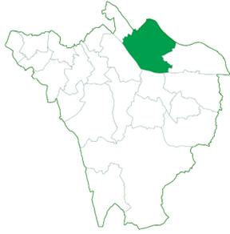
Chislehurst
 | Child population aged 0-2 years 2024-2025 | 485  (469 in 25-26)
 | Child population aged 3-4 years 2024-2025 | 347  (337 in 25-26)
 | Child population aged 5-14 years 2024-2025 | 1963  (1958 in 25-26) | Total child population for this ward is 2,795 for the academic year 2024-2025. With an estimated population for 2025-2026 of 2,764 children, a slight decrease in population growth.
 | Childcare Places  In Preschools, Day Nurseries and Childminders | 451 | This ward has seen a decrease in available 0-4-year-old childcare places since the last assessment, due to childminders closing. There is one new day nursery proposed with Ofsted.
 | The total number of providers | Childminders 9 | Preschools  8 | Day Nurseries  3
Ratio | Ratio of childcare places to children | Population 0-4 years  832 | Registered places  451 | Childcare ratio  0.54
 | Quality  Outstanding, Good and Not yet Inspection | 100% | This is an area where the quality of childcare on offer to parents is high.

​  New homes being developed 2025 - 2028 | ​61
​  ​Is this a priority area for additional provision? | No

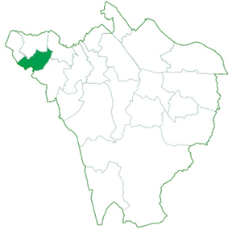
Clockhouse
 | Child population aged 0-2 years 2024-2025 | 715  (702 in 25-26)
 | Child population aged 3-4 years 2024-2025 | 473  (465 in 25-26)
 | Child population aged 5-14 years 2024-2025 | 2136  (2088 in 25-26) | Total child population for this ward is 3,324 for the academic year 2024-2025. With an estimated population for 2025-2026 of 3,255 children, a slight increase in population growth.
 | Childcare Places  In Preschools, Day Nurseries and Childminders | 596 | This ward has seen a decrease in available 0-4-year-old childcare places since the last assessment, due to childminders closing. One day nursery is planning to increase places this year.
 | The total number of providers | Childminders 33 | Preschools  3 | Day Nurseries  6
Ratio | Ratio of childcare places to children | Population 0-4 years  1188 | Registered places  596 | Childcare ratio  0.50
 | Quality  Outstanding, Good and Not yet Inspection | 98% | This is an area where the quality of childcare on offer to parents is high.

​  New homes being developed 2025 - 2028 | ​105
​  ​Is this a priority area for additional provision? | Not Yet

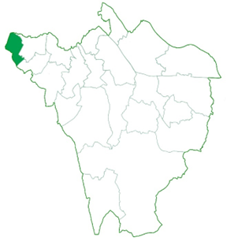
Crystal Palace & Anerley
 | Child population aged 0-2 years 2024-2025 | 454  (452 in 25-26)
 | Child population aged 3-4 years 2024-2025 | 311  (342 in 25-26)
 | Child population aged 5-14 years 2024-2025 | 1175  (1180 in 25-26) | Total child population for this ward is 1,940 for the academic year 2024-2025. With an estimated population for 2025-2026 of 1,909 children, a slight decrease in population growth.
 | Childcare Places  In Preschools, Day Nurseries and Childminders | 209 | This ward has seen an increase in available 0-4-year-old childcare places since the last assessment. There is a shortage of halls to hire as a pre-school in the area. New homes will increase demand.
 | The total number of providers | Childminders 5 | Preschools  1 | Day Nurseries  3
Ratio | Ratio of childcare places to children | Population 0-4 years  765 | Registered places  209 | Childcare ratio  0.27
 | Quality  Outstanding, Good and Not yet Inspection | 100% | This is an area where the quality of childcare on offer to parents is high.

​  New homes being developed 2025 - 2028 | ​226
​  ​Is this a priority area for additional provision? | Yes

Darwin
 | Child population aged 0-2 years 2024-2025 | 130  (125 in 25-26)
 | Child population aged 3-4 years 2024-2025 | 84  (92 in 25-26) | 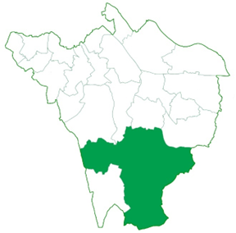
 | Child population aged 5-14 years 2024-2025 | 643  (623 in 25-26) | Total child population for this ward is 857 for the academic year 2024-2025. With an estimated population for 2025-2026 of 840 children, a slight decrease in population growth.
 | Childcare Places  In Preschools, Day Nurseries and Childminders | 28 | This ward has seen an increase in available 0-4-year-old childcare places since the last assessment. There are no academy nursery classes in this ward.
 | The total number of providers | Childminders 4 | Preschools  0 | Day Nurseries  0
Ratio | Ratio of childcare places to children | Population 0-4 years  214 | Registered places  28 | Childcare ratio  0.13
 | Quality  Outstanding, Good and Not yet Inspection | 100% | This is an area where the quality of childcare on offer to parents is high.

​  New homes being developed 2025 - 2028 | ​9
​  ​Is this a priority area for additional provision? | Not Yet

Farnborough & Crofton
 | Child population aged 0-2 years 2024-2025 | 423  (423 in 25-26)
 | Child population aged 3-4 years 2024-2025 | 353  (338 in 25-26) | 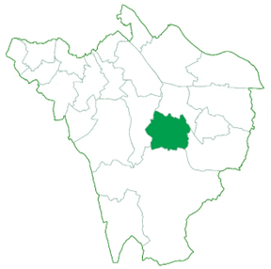
 | Child population aged 5-14 years 2024-2025 | 2416  (2430 in 25-26) | Total child population for this ward is 3,192 for the academic year 2024-2025. With an estimated population for 2025-2026 of 3,191 children, a slight decrease in population growth.
 | Childcare Places  In Preschools, Day Nurseries and Childminders | 462 | This ward has seen an increase in available 0-4-year-old childcare places since the last assessment.
 | The total number of providers | Childminders 30 | Preschools  4 | Day Nurseries  3
Ratio | Ratio of childcare places to children | Population 0-4 years  766 | Registered places  462 | Childcare ratio  0.60
 | Quality  Outstanding, Good and Not yet Inspection | 100% | This is an area where the quality of childcare on offer to parents is high.

​  New homes being developed 2025 - 2028 | ​46
​  ​Is this a priority area for additional provision? | No

Hayes & Coney Hall
 | Child population aged 0-2 years 2024-2025 | 371  (353 in 25-26)
 | Child population aged 3-4 years 2024-2025 | 298  (317 in 25-26) | 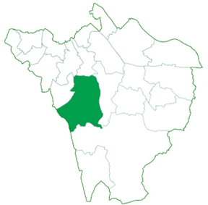
 | Child population aged 5-14 years 2024-2025 | 2131  (2103 in 25-26) | Total child population for this ward is 2,800 for the academic year 2024-2025. With an estimated population for 2025-2026 of 2,773 children, a slight decrease in population growth.
 | Childcare Places  In Preschools, Day Nurseries and Childminders | 427 | This ward has seen a decrease in available 0-4-year-old childcare places since the last assessment, due to childminders closing.
 | The total number of providers | Childminders 19 | Preschools  6 | Day Nurseries  1
Ratio | Ratio of childcare places to children | Population 0-4 years  669 | Registered places  427 | Childcare ratio  0.63
 | Quality  Outstanding, Good and Not yet Inspection | 100% | This is an area where the quality of childcare on offer to parents is high.

​  New homes being developed 2025 - 2028 | ​12
​  ​Is this a priority area for additional provision? | No

Kelsey & Eden Park
 | Child population aged 0-2 years 2024-2025 | 446  (452 in 25-26) | 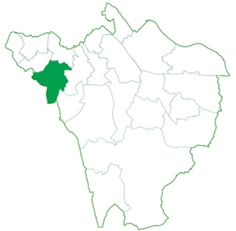
 | Child population aged 3-4 years 2024-2025 | 334  (334 in 25-26)
 | Child population aged 5-14 years 2024-2025 | 2084  (2075 in 25-26) | Total child population for this ward is 2,864 for the academic year 2024-2025. With an estimated population for 2025-2026 of 2,861 children, a slight decrease in population growth.
 | Childcare Places  In Preschools, Day Nurseries and Childminders | 598 | This ward has seen an increase in available 0-4-year-old childcare places since the last assessment. With one new day nursery with 107 places. There are no academy nursery classes in this ward.
 | The total number of providers | Childminders 13 | Preschools  4 | Day Nurseries  5
Ratio | Ratio of childcare places to children | Population 0-4 years  780 | Registered places  598 | Childcare ratio  0.76
 | Quality  Outstanding, Good and Not yet Inspection | 100% | This is an area where the quality of childcare on offer to parents is high.

​  New homes being developed 2025 - 2028 | ​112
​  ​Is this a priority area for additional provision? | No

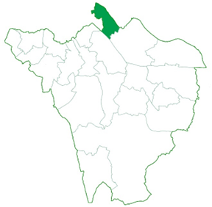
Mottingham
 | Child population aged 0-2 years 2024-2025 | 404  (377 in 25-26)
 | Child population aged 3-4 years 2024-2025 | 293  (285 in 25-26)
 | Child population aged 5-14 years 2024-2025 | 1576  (1558 in 25-26) | Total child population for this ward is 2,482 for the academic year 2024-2025. With an estimated population for 2025-2026 of 2462 children, a slight decrease in population growth.
 | Childcare Places  In Preschools, Day Nurseries and Childminders | 259 | This ward has seen a decrease in available 0-4-year-old childcare places since the last assessment, with the closure of two pre-schools. There are some concerns over a shortage of places for two year olds, in group provision. A new school-based nursery will be opening in the Autumn term with 30 places for 3 & 4 year olds.
 | The total number of providers | Childminders 16 | Preschools  1 | Day Nurseries  2
Ratio | Ratio of childcare places to children | Population 0-4 years  697 | Registered places  259 | Childcare ratio  0.37
 | Quality  Outstanding, Good and Not yet Inspection | 100% | This is an area where the quality of childcare on offer to parents is high.

​  New homes being developed 2025 - 2028 | ​21
​  ​Is this a priority area for additional provision? | Yes

Orpington
 | Child population aged 0-2 years 2024-2025 | 428  (432 in 25-26) | 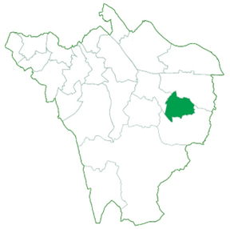
 | Child population aged 3-4 years 2024-2025 | 274  (280 in 25-26)
 | Child population aged 5-14 years 2024-2025 | 1544  (1554 in 25-26) | Total child population for this ward is 2,246 for the academic year 2024-2025. With an estimated population for 2025-2026 of 2,266 children, a slight increase in population growth.
 | Childcare Places  In Preschools, Day Nurseries and Childminders | 121 | This ward has seen a decrease in available 0-4-year-old childcare places since the last assessment. There will be a school-based nursery in this ward opening Autumn 25, and a new childminder proposed with Ofsted. There is a shortage of group provision in this ward. The planned new housing will also increase pressure for childcare places in this ward.
 | The total number of providers | Childminders 7 | Preschools  2 | Day Nurseries  0
Ratio | Ratio of childcare places to children | Population 0-4 years  702 | Registered places  121 | Childcare ratio  0.17
 | Quality  Outstanding, Good and Not yet Inspection | 100% | This is an area where the quality of childcare on offer to parents is high.

​  New homes being developed 2025 - 2028 | ​218
​  ​Is this a priority area for additional provision? | Yes
Penge & Cator
 | Child population aged 0-2 years 2024-2025 | 810  (803 in 25-26)
 | Child population aged 3-4 years 2024-2025 | 492  (501 in 25-26) | 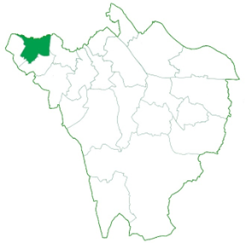
 | Child population aged 5-14 years 2024-2025 | 2184  (2158 in 25-26) | Total child population for this ward is 3,486 for the academic year 2024-2025. With an estimated population for 2025-2026 of 3,462 children, a slight decrease in population growth.
 | Childcare Places  In Preschools, Day Nurseries and Childminders | 756 | This ward has seen a decrease in available 0-4-year-old childcare places since the last assessment. Two childminders are on support plans. A school-based nursery will be increasing places Spring 2026.
 | The total number of providers | Childminders 14 | Preschools  10 | Day Nurseries  8
Ratio | Ratio of childcare places to children | Population 0-4 years  1302 | Registered places  756 | Childcare ratio  0.58
 | Quality  Outstanding, Good and Not yet Inspection | 95% | This is an area where the quality of childcare on offer to parents is high.

​  New homes being developed 2025 - 2028 | ​131
​  ​Is this a priority area for additional provision? | No

Petts Wood & Knoll
 | Child population aged 0-2 years 2024-2025 | 580  (555 in 25-26)
 | Child population aged 3-4 years 2024-2025 | 423  (430 in 25-26) | 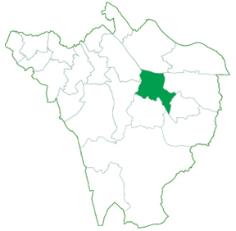
 | Child population aged 5-14 years 2024-2025 | 2375  (2369 in 25-26) | Total child population for this ward is 3,378 for the academic year 2024-2025. With an estimated population for 2025-2026 of 3,354 children, a slight decrease in population growth.
 | Childcare Places  In Preschools, Day Nurseries and Childminders | 714 | This ward has seen a decrease in available 0-4-year-old childcare places since the last assessment. One pre-school has closed in this ward, there is a new proposed day nursery to open in Autumn 2025.
 | The total number of providers | Childminders 19 | Preschools  9 | Day Nurseries  6
Ratio | Ratio of childcare places to children | Population 0-4 years  1003 | Registered places  714 | Childcare ratio  0.71
 | Quality  Outstanding, Good and Not yet Inspection | 98% | This is an area where the quality of childcare on offer to parents is quite high, just one provider judged Requires Improvement from Ofsted.

​  New homes being developed 2025 - 2028 | ​38
​  ​Is this a priority area for additional provision? | No

Plaistow
 | Child population aged 0-2 years 2024-2025 | 435  (420 in 25-26) | 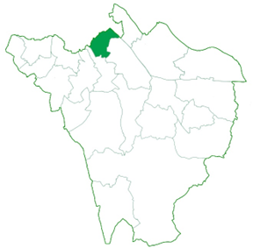
 | Child population aged 3-4 years 2024-2025 | 317  (293 in 25-26)
 | Child population aged 5-14 years 2024-2025 | 1711  (1699 in 25-26) | Total child population for this ward is 2,463 for the academic year 2024-2025. With an estimated population for 2025-2026 of 2,412 children, a slight decrease in population growth.
 | Childcare Places  In Preschools, Day Nurseries and Childminders | 537 | This ward has seen a decrease in available 0-4-year-old childcare places since the last assessment. Due to closing childminders.
 | The total number of providers | Childminders 16 | Preschools  4 | Day Nurseries  4
Ratio | Ratio of childcare places to children | Population 0-4 years  752 | Registered places  537 | Childcare ratio  0.71
 | Quality  Outstanding, Good and Not yet Inspection | 100% | This is an area where the quality of childcare on offer to parents is high.

​  New homes being developed 2025 - 2028 | ​76
​  ​Is this a priority area for additional provision? | No

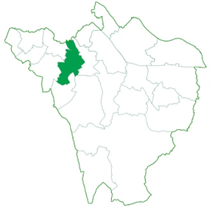
Shortlands & Park Langley
 | Child population aged 0-2 years 2024-2025 | 514  (502 in 25-26)
 | Child population aged 3-4 years 2024-2025 | 422  (398 in 25-26)
 | Child population aged 5-14 years 2024-2025 | 2161  (2138 in 25-26) | Total child population for this ward is 3,097 for the academic year 2024-2025. With an estimated population for 2025-2026 of 3,038 children, a slight decrease in population growth.
 | Childcare Places  In Preschools, Day Nurseries and Childminders | 329 | This ward has seen a decrease in available 0-4-year-old childcare places since the last assessment. One school-based nursery will be increasing capacity in the Autumn term 2025. The childcare ratio is low in this area.
 | The total number of providers | Childminders 13 | Preschools  3 | Day Nurseries  3
Ratio | Ratio of childcare places to children | Population 0-4 years  936 | Registered places  329 | Childcare ratio  0.35
 | Quality  Outstanding, Good and Not yet Inspection | 100% | This is an area where the quality of childcare on offer to parents is high.

​  New homes being developed 2025 - 2028 | ​12
​  ​Is this a priority area for additional provision? | Yes

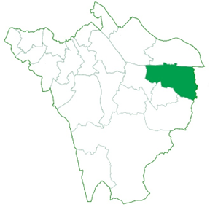
St Marys Cray
 | Child population aged 0-2 years 2024-2025 | 678  (662 in 25-26)
 | Child population aged 3-4 years 2024-2025 | 488  (473 in 25-26)
 | Child population aged 5-14 years 2024-2025 | 2358  (2315 in 25-26) | Total child population for this ward is 3,524 for the academic year 2024-2025. With an estimated population for 2025-2026 of 3,450 children, a slight decrease in population growth.
 | Childcare Places  In Preschools, Day Nurseries and Childminders | 410 | This ward has seen an increase in available 0-4-year-old childcare places since the last assessment. The volume of pre-school provision is high in this ward, which is in line with need.
 | The total number of providers | Childminders 18 | Preschools  7 | Day Nurseries  1
Ratio | Ratio of childcare places to children | Population 0-4 years  1166 | Registered places  410 | Childcare ratio  0.35
 | Quality  Outstanding, Good and Not yet Inspection | 98% | This is an area where the quality of childcare on offer to parents is high.

​  New homes being developed 2025 - 2028 | ​39
​  ​Is this a priority area for additional provision? | No

St Pauls Cray
 | Child population aged 0-2 years 2024-2025 | 664  (616 in 25-26)
 | Child population aged 3-4 years 2024-2025 | 460  (475 in 25-26) | 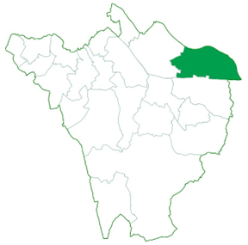
 | Child population aged 5-14 years 2024-2025 | 2472  (2410 in 25-26) | Total child population for this ward is 3,596 for the academic year 2024-2025. With an estimated population for 2025-2026 of 3,501 children, a slight decrease in population growth.
 | Childcare Places  In Preschools, Day Nurseries and Childminders | 521 | This ward has seen a decrease in available 0-4-year-old childcare places since the last assessment, due to a school closing their nursery class. However, a new provider will be moving in during Autum 2025.
 | The total number of providers | Childminders 14 | Preschools  3 | Day Nurseries  4
Ratio | Ratio of childcare places to children | Population 0-4 years  1124 | Registered places  521 | Childcare ratio  0.46
 | Quality  Outstanding, Good and Not yet Inspection | 100% | This is an area where the quality of childcare on offer to parents is high.

​  New homes being developed 2025 - 2028 | ​42
​  ​Is this a priority area for additional provision? | No

West Wickham
 | Child population aged 0-2 years 2024-2025 | 334  (322 in 25-26)
 | Child population aged 3-4 years 2024-2025 | 276  (271 in 25-26) | 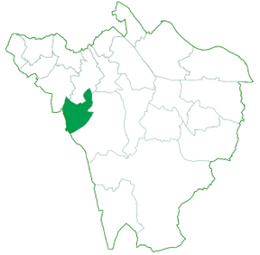
 | Child population aged 5-14 years 2024-2025 | 1798  (1805 in 25-26) | Total child population for this ward is 2,408 for the academic year 2024-2025. With an estimated population for 2025-2026 of 2,398 children, a slight decrease in population growth.
 | Childcare Places  In Preschools, Day Nurseries and Childminders | 326 | This ward has seen a decrease in available 0-4-year-old childcare places since the last assessment, due to childminders closing. There are two childminders proposed and a new school-based nursery to open in the Autum term.
 | The total number of providers | Childminders 18 | Preschools  6 | Day Nurseries  3
Ratio | Ratio of childcare places to children | Population 0-4 years  610 | Registered places  326 | Childcare ratio  0.53
 | Quality  Outstanding, Good and Not yet Inspection | 100% | This is an area where the quality of childcare on offer to parents is high.

​  New homes being developed 2025 - 2028 | ​64
​  ​Is this a priority area for additional provision? | No

