Best Start in Life
in Bromley

  - Plan for 2026 onwards

Contents

Welcome 3
Vision 4
Our vision 4
Our dream 4
Our ambitions 4
About Bromley 6
Where our children live 6
Deprivation (IMD) decile 6
SEND 7
First language 7
Further details 8
Future updates 8
What’s happening in Bromley now 9
Child outcomes in Bromley 9
Early years ecosystem 10
Children and Family Centres 11
Childcare and Early Years Education 13
Delivering our Ambitions 16
Ambition 1 - Our children 16
Ambition 2 - Our families 20
Ambition 3 - Our practitioners 21
Ambition 4 - Our resources 22
Accountability and governance 23
Appendix A: Digging deeper - Good Level of Development 24
Appendix B: Digging deeper - ASQ-3 assessment 26
Appendix C: Vaccinations and immunisations 27
Uptake of the 6-in-1 vaccine 27
Uptake of MMR vaccinations 27

Welcome

In Bromley, we have a strong track record of early intervention and early help, which was pulled together into a single Early Help Strategy for children (aged from birth to 18) and their families: Our vision for 2030 in 2022.

We know that the first 1,001 days from conception to age 2 are a unique period for a baby that sets the foundations for lifelong emotional and physical wellbeing.

Giving Every Child the Best Start in Life is the Government’s strategy published in July 2025 for improving child health and development across the country to break the link between a child's background and their future success. At the heart of the Government’s strategy is an ambition that 75% of 5-year-olds in England have a good level of development by 2028.

The Best Start in Life programme forms an essential element of the enhancement and next phase of our Early Help Strategy, which will support us to achieve our dream. Therefore, this Plan refers to, and is shaped by, our wider Early Help Strategy for Bromley and it will help to ensure that this ambition is achieved in Bromley.

This plan is designed to inform and influence the discussions held in the borough to identify, agree and implement the changes required to deliver our vision and achieve our dream. It is a live document which is updated regularly as the borough continues to embed significant transformation programmes across children’s services. This ensures that the plan remains relevant, flexible and responsive to our implementation of the Best Start in Life programme.

An action plan will be developed during 2026 pulling together the different strands of work to implement the priorities and actions identified in this plan. This will be overseen, monitored and evaluated by the Best Start in Life Working Group which reports to the Early Help Strategic Board.

Further updates to this plan and the action plan will be published as we implement this exciting programme to give each child the best start in life in our borough.

Janet Bailey, Director of Children, Education and Families

Vision

Our Early Help Strategy is rightly ambitious for the wider workforce supporting families living in Bromley (‘us’) and for our children and their families. It sets out how we are collectively working to achieve our vision.

Our vision

Making Bromley an excellent place for children to grow up, thrive and have the best life chances in families who flourish and are happy to call Bromley home.

Our dream

We have a clear dream which will help us to achieve this vision:

Our early help ecosystem makes sure that every child in Bromley has a bright, safe and optimistic future.

Our ambitions

The implementation of the Best Start in Life programme will further support us to achieve this dream and the achievement of four interlocking ambitions. Each ambition is focused on one of the four quadrants that make up our early help model – our children, our families, our practitioners and our resources:

- Ambition 1 - Our children experience loving and safe homes with consistent and positive parenting which nurtures them and helps them flourish.
- Ambition 2 - Our families are informed about the range of services and support available to them, and how to use them when they need it, so they can be in control of their own lives.
- Ambition 3 - Our practitioners work within a culture that embraces relational and compassionate practice where the strengths of our families are understood and built upon.
- Ambition 4 - Our resources are focused on providing responsive, dynamic and holistic integrated services across health, education and social care which identify need and provide support at the earliest opportunity to meet needs and prevent escalation of concern.

About Bromley

There are approximately 330,000 people living in our borough in an estimated 135,000 households.

Approximately 78,400 of these are children aged 19 and under:

- 23,001 children aged 0-5
- 25,134 children aged 6-11
- 24,391 children aged 12-17
- 5,821 children aged 18-19

Where our children live

The following map highlights the areas of the borough with high and low numbers of young children (aged 5 and under).

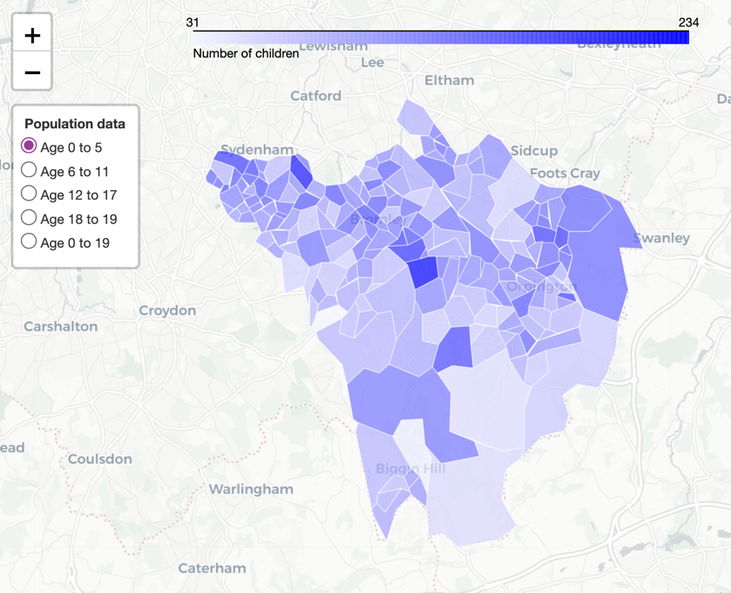

Deprivation (IMD) decile

In 2024/25, there were 53,086 children eligible for free school meals in Bromley across all state-funded primary and secondary schools. In 2025, 34.1% (370) of homeless households had dependent children, including 297 single-parent households. Over 1,200 families are registered for the Healthy Start scheme in Bromley.
The following map highlights the areas of the borough with high levels of deprivation.

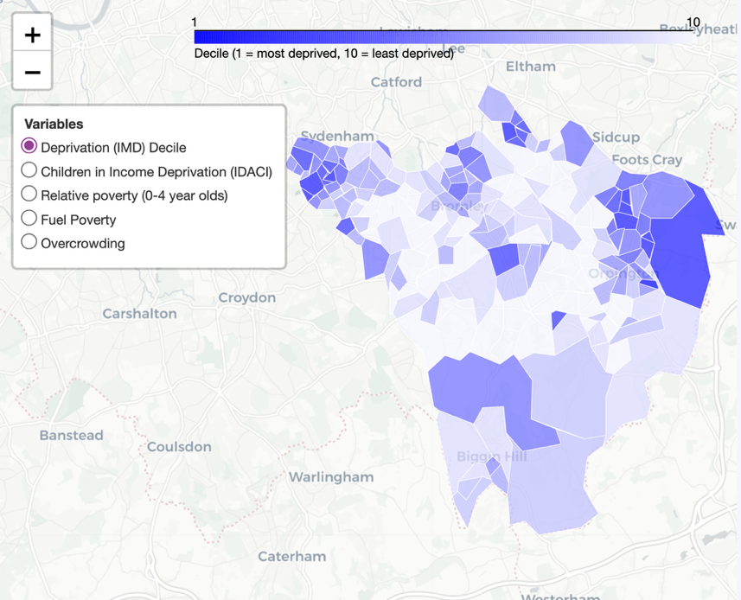

SEND

In the 2024/25 academic year, 9,686 pupils in Bromley were identified as having Special Educational Needs.

Of these, Speech, Language and Communications needs is the most common primary need (2,638 pupils). This is particularly seen in the 0-2 year old population (57%).

First language

The 2021 census recorded that 8.1% residents in Bromley speak a language other than English as their main language at home. The top 5 identified languages were:

- Polish
- Romanian
- Italian
- Tamil
- All other Chinese

Further details

Our Early Help Strategy provides detailed information on the people who live in Bromley including households, population, ethnicity, births, deprivation and more.

Future updates

The Council and NHS partners will be updating the full children’s JSNA by summer 2026. This section of the plan will be updated to reflect that data.

The council website provides details of previous JSNA’s - www.bromley.gov.uk/jsna.

What’s happening in Bromley now

Child outcomes in Bromley

Good Level of Development

Children in Bromley have a strong start in life. A higher proportion (+5%) achieve a Good Level of Development (GLD) than the national average (73.3% compared to 68.3%).

There are however notable differences in communities of children across the borough which mirrors the national picture:

- Fewer children eligible for Free School Meals (FSM) achieve a GLD than their peers.
- Fewer boys achieve a good GLD than girls.
- Fewer children whose first language is not English achieve a good GLD than their peers.
- Fewer children born in the summer term achieve a good GLD than their peers.
- Fewer children from Black/African/Caribbean or Other heritages achieve a good GLD than their peers.
- Significantly fewer children with identified SEN achieve a good GLD than their peers.

We have embraced the government’s stretching targets of ensuring that at least 80% of our children achieve a GLD and 61.5% for those eligible for FSM by 2027/28. This equates to an additional 249 children overall with an additional 31 children eligible for FSM to reach the relevant targets.

Further details are provided in Appendices A and B.

Vaccinations and immunisations

Whilst most children in Bromley are receiving the recommended vaccinations and immunisations on time, there has been a general downward trend in the uptake of these across all vaccines during the last decade.

- Fewer children in Bromley receive the 6-in-1 vaccine at 12 months than the national average.
- Fewer children in Bromley receive the MMR vaccine at 2 years old than the national average.
- Fewer children in Bromley receive the MMR vaccine (single and double doses) at 5 years old than the national average.

Vaccine hesitancy and misinformation

Falling uptake weakens population (‘herd’) immunity, leaving more children unprotected, and making outbreaks like measles more likely, especially in under‑vaccinated communities and education settings.

Bromley’s Public Health Team regularly review local vaccination data with NHS partners and Immunisation Boards so we can focus support where uptake is lowest. We provide outreach and attend events in communities with lower uptake; providing information and pop‑up clinics and working closely with schools and early years settings. We also train staff across health, education and community services to have confident, supportive conversations about vaccines, addressing vaccine hesitancy and misinformation with clear, trusted advice, and encouraging families to get vaccinated on time.

Further details are provided in Appendix C.

Early years ecosystem

Bromley has well-established and mature early help arrangements in place which make a difference to children and families.

At the heart of this are our Early Intervention and Family Support (EIFS) and universal health visiting services. We believe that our continued investment in our early help services is critical to successfully diverting children away from statutory intervention. This gives us strong foundations to build on.

As the Family First programme evolves, this will build upon, reshaping and strengthening Bromley’s early help model, as partners commit to this new agenda.

Resources and opportunities

The following image illustrates the early help ecosystem across our borough. Split into four layers, it can help to visualise the collective nature of early help which, by working together, helps create nurturing homes and thriving childhoods:

- Black - The child and the family at the centre
- Green - Support by their relatives, friends and local community that help keep them resilient and build on their own strengths
- Magenta - Universal services such as schools, GPs, employment and social support are shown in across four life areas – health, community, learning and money
- Wine - The more specialist services that dip into early help, and which families can use when they have more complex needs

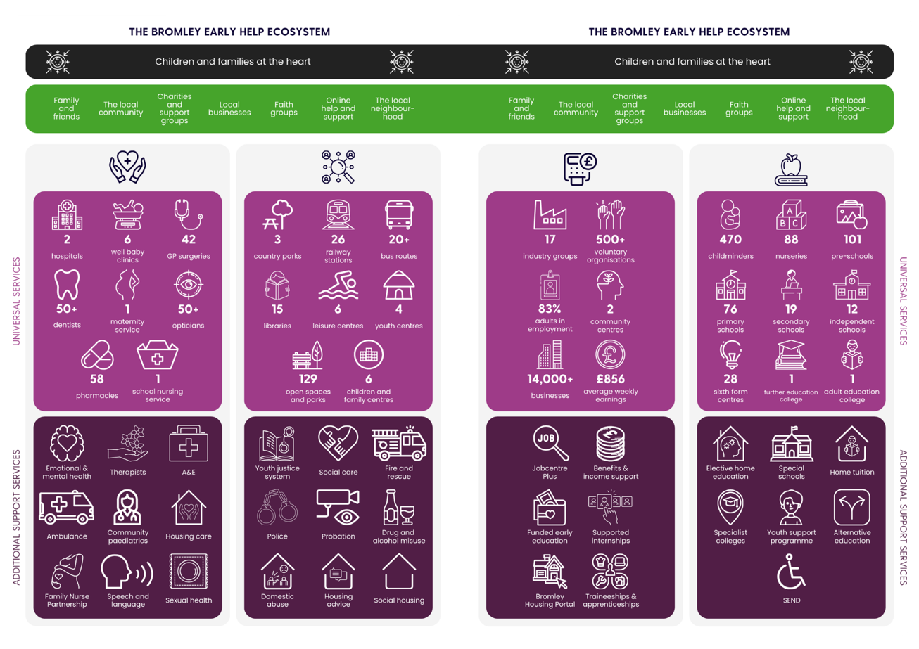

Children and Family Centres

The following maps show areas of the borough with high & low numbers of young children (aged 5 and under) and those with high levels of deprivation. The third map shows the location of our existing six Children & Family Centres which are based in areas of greatest need:

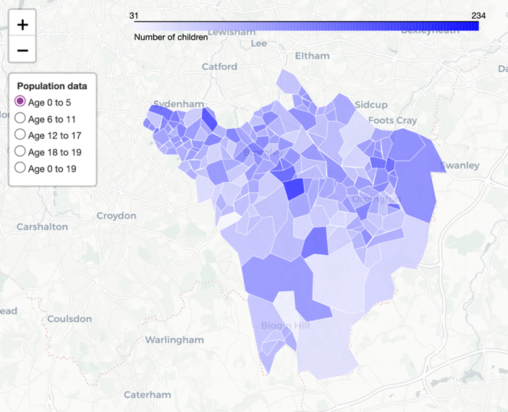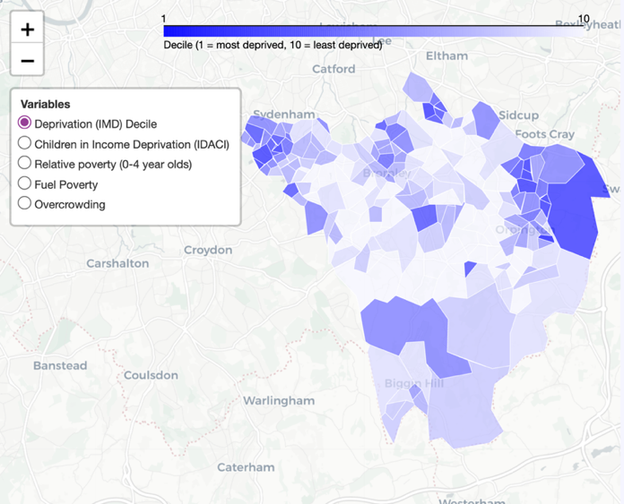
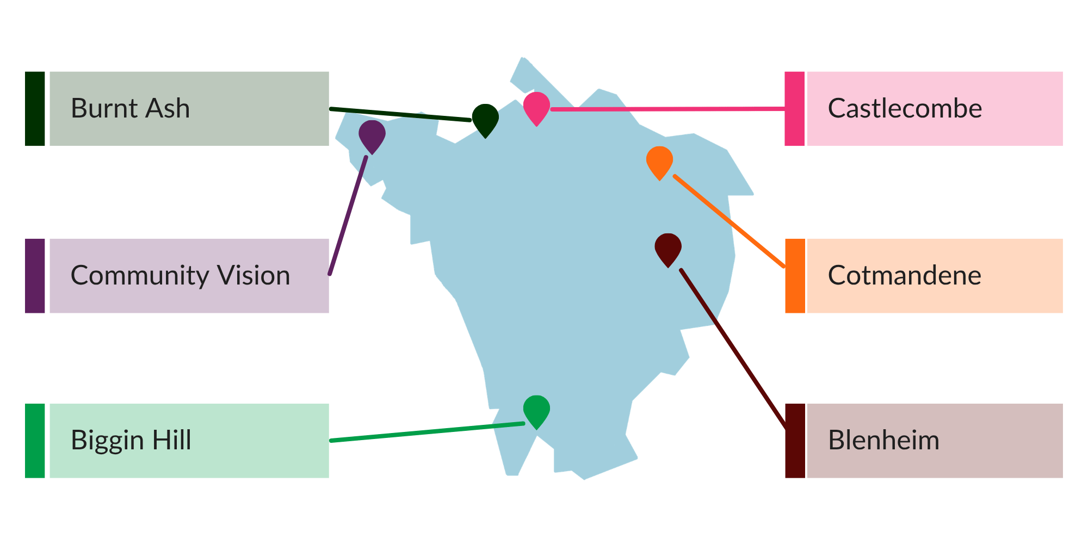

Best Start Family Hubs

Alongside this plan, we are reviewing our existing network of six Children and Family Centres across the borough in line with Best Start Family Hubs, identifying any gaps in provision and strengthening partnership working.

Government agendas in relation to children and young people are being considered collectively, which means that this is happening alongside the wider Children’s Social Care Reforms, Integrated Neighbourhood Teams, Children’s Wellbeing and Schools Bill and Youth Matters.

Childcare and Early Years Education

Ensuring sufficient provision

Bromley assesses the need for childcare annually as part of its Educational Commissioning Plan. The plan provides a borough‑wide and school place planning area review of childcare for children aged 0–14. Early Years providers, schools, and parents contribute to our review of childcare sufficiency through an annual survey, enabling analysis of supply, demand, and ward‑level pressures. Resulting actions are monitored regularly and reported annually to Members. The Educational Commissioning Plan and the Ward Data Reports are published online to support provider planning and inform families about potential areas of required expansion.

Early Years Education - entitlements, quality and support

The Early Years Quality Team will continue to deliver targeted training to providers on improving the Home Learning Environment (HLE), enabling practitioners to guide families in home‑based learning activities. Collaborative work with Family Hubs will ensure consistent support for vulnerable families to improve outcomes, including children’s GLD. Termly Early Years Partnership Meetings - provider‑led and supported by the Early Years Team - serve as a regular forum for multi‑agency updates, including standing SEND items from the Early Years Inclusion Team.

Information on Early Years childcare entitlements is publicly available through the Council website, supported by leaflets for providers and families. The Early Years Childcare Information Officer assists parents in understanding local childcare options and available funding. The Early Years Team also attends outreach sessions in Children and Family Centres to promote childcare choices and early access to funded entitlements.

The Early Years Team administers the majority of Early Years SEN Inclusion Fund (EY SENIF) and Early Years Education, Health and Care Plan (EY EHCP) funding, in partnership with the Early Years Inclusion Team. The funding is allocated as part of a package of support and advice from the Early Years Inclusion Team following a referral to them for individual child. This ensures timely monthly payments to providers and ongoing monitoring of children’s progress by the Inclusion Team. The DfE provides the council with details of families potentially eligible for two‑year‑old funded places due to economic vulnerability. The Early Years Team proactively contact these families to support take‑up and signposts them to Children and Family Centres for additional support.

Annual Early Years Foundation Stage Profile (EYFSP) outcomes are reviewed by the Early Years Quality Team to identify emerging needs across the borough. Training aligned to these findings is then offered to all Early Years providers, including maintained nursery classes, to support continuous quality improvement.

Early Years Expansion Grant

We have sought to use the Early Years Expansion Grant to increase provision for 2-year-olds at private, voluntary and independent (PVI) nurseries, which make up the bulk of provision in Bromley.

National Wraparound Childcare Programme

The National Wraparound Childcare Programme, while focused on primary‑aged children, is a key enabler across several Best Start in Life themes. High‑quality wraparound childcare supports parents into sustainable employment, strengthens continuity of care for children across the early years and primary phases, and promotes a more integrated family support system. It also plays an important role in inclusive practice, particularly for children with SEND, and supports professional development across the early years and childcare workforce.

By ensuring sufficient childcare provision between 8am and 6pm during term time, the programme enables more parents - particularly mothers, single parents, and those in lower‑income or insecure employment - to take up, sustain, or extend work opportunities. This supports improved family financial resilience, reduces childcare‑related barriers to employment, and aligns with Bromley’s ambitions to strengthen family stability and independence.

As part of Bromley’s implementation approach, wraparound childcare will be developed through collaborative models involving schools, PVI settings, childminders, academy trusts, and community organisations to ensure provision that is flexible, responsive to local needs, and able to draw on the strengths of all sectors.

The programme also presents a significant opportunity to improve the way families navigate the system. Children and Family Centres act as a central point where wraparound childcare information is clearly signposted, enabling families to easily access details about availability, eligibility, and local providers. Improved parental information pathways will increase awareness, provide families access support at the earliest opportunity, and drive effective take‑up of services.

Looking ahead, Bromley will continue to integrate wraparound childcare within the broader Early Help and Best Start in Life plan, ensuring it contributes to smoother transitions between early years settings and primary school and greater access to support for families who may otherwise not engage with services.

School Based Nursery Programme

Bromley’s approach in the first two Phases of the school-based nursery programme has been to target increasing school-based nursery provision in areas of deprivation that have demonstrable need.

Early Years Inclusion

To strengthen support for vulnerable children, the Early Years Inclusion Team is mapping inclusive and specialist SEND provision across the borough to identify gaps and inform future planning. As part of Department for Education (DfE) School Based Nursery initiatives, Phase Three we will be prioritising school‑based nursery provision that meets the needs of younger children with SEND, focusing on both specialist and inclusive models within Bromley’s most disadvantaged areas.

Delivering our Ambitions

Our Early Help Strategy is shaped around four interlocking ambitions. Each ambition is focused on one of the four quadrants that make up our early help (and Best Start in Life) model – our children, our families, our practitioners and our resources.

Ambition 1 - Our children

Our Ambition

Our children experience loving and safe homes with consistent and positive parenting which nurtures them and helps them flourish.

What we will do

Maternal and early years health services

Why this is important

Evidence shows that place-based services that offer families a single point of access to different types of support are a cost-efficient way of ensuring the healthy development of babies and young children, breaking the link between family background and life chances.

Our top 3 priorities

- Evaluate our system improvements for Health Visiting and Early Years Settings Integrated 2/2.5-Year Reviews we implemented following learning from a 2024 deep dive into one hundred cases of pre-school children to improve identification of developmental delays.
- Ensuring our Children and Family Centres continue to act as a single point of access to a range of different sources of support for families with new babies.
- Improve uptake of routine childhood vaccines through partnership working, targeted outreach where uptake is lowest, and clear, trusted messaging to counter vaccine hesitancy and misinformation.

Measures of progress

- Annual footfall in the Children and Family Centres
- Vaccination rates
- Audit of ASQ pathways and outcomes

Home learning environment and parenting programmes

Why this is important

Evidence shows that home learning environment and parenting programmes can lead to meaningful changes in parent behaviours, and subsequent positive impacts on child outcomes. This means they are a core mechanism we can use to help achieve our Ambitions.

Our teams will work with practitioners to cascade information and knowledge so that parents and carers have the skills to support children’s early language in the home learning environment.

Our top 3 priorities

- Implement the HLE Peeps programme across Bromley’s workforce.
- Ensure our parenting programme delivery is offered at all our Children and Family Centres across the borough.
- Monthly review of our Best Start in Life website pages to ensure relevance, current best practice and easy access to resources for families.

Measures of progress

- Parenting programme enrolments and completion rates
- Best Start in Life website analytics
- Family feedback

Early childhood education and care access and quality

Why this is important

Early childhood education and care (ECEC) can have an impact on children's language, physical and social-emotional development, and its impact is greatest for children from more deprived backgrounds. Since nearly all children access ECEC before age four, providing and supporting high-quality ECEC provision is a key lever for delivering strong child outcomes.

Our top 3 priorities

- Promote educational inclusion for all by continuing to provide high quality and timely information through a range of sources to support families and children.
- Work with local early years settings and childminders to increase the number of Early Years places provided for vulnerable children and those with SEN.
- Strengthen the universal and targeted elements of the SLCN Graduated Approach to support for families, with a focus on upskilling Early Years providers, including childminders.

Measures of progress

- Take-up of childcare entitlements
- Reduction in the number of clinical referrals to SALT
- Number of ECEC spaces in areas of highest need
- Early years practitioner training courses

Transition to school and reception year

Why this is important

While we recognise that much of the beneficial practice that enables a smooth transition to school sits with settings and schools, we recognise the importance of the wider system providing support for these practices through things like information sharing via the Early Years Transition Event for providers and receiving schools, and training for the wider workforce.

Our top 3 priorities

- Develop School Readiness Transition Events for parents hosted through the Children and Family Centres.
- Offer training targeted at early years providers, that contribute to the promotion of school readiness in preschool children.
- Increase the percentage of children receiving their first choice of placement at primary school through clear and open information in the school Admissions process.

Measures of progress

- Child, parent, setting and school feedback
- Percentage of families receiving first choice of primary school
- Reduction in the percentage of admissions appeals at primary age

SEND support

Why this is important

Evidence consistently shows that children with SEND are less likely to attain a GLD. There are many opportunities to improve their experiences, and many of the practices that support children with SEND are beneficial for all children.

Our top 3 priorities

- Make sure that our early years settings and reception classes are effective in ensuring children who have SEND make good progress in their learning and in their personal and social development.
- Further embed our graduated approach across Education, Health, and Social Care for all children focusing on early intervention, assessment, planning, and support through partnership with families, agencies and the voluntary sector.
- Improve services for children with social communication difficulties including autism by transforming the Bromley Children and Young People Integrated Therapies (Physiotherapy, Speech & Language, and Occupational Therapy) commissioning and provision through co-production.

Measures of progress

- Family feedback on ability to access quality SEND advice from all services/partners
- Feedback gathered through the annual SEND Local Offer survey
- Increase in the number of children with SEN Support in mainstream Reception

Ambition 2 - Our families

Our Ambition

Our families are informed about the range of services and support available to them, and how to use them when they need it, so they can be in control of their own lives.

What we will do

Family involvement

We believe that our families want to be in control of their own lives and be as
self-sufficient as possible. That’s why we will provide a range of accessible information to help them to make choices about their lives. By giving families the information they need, when and where they need it, we will empower them to make informed choices that benefit them and improve the lives of their children.

Our top 3 priorities

- We will use our annual Child’s Voice report to highlight how the voice of children and families has been captured through the delivery of our engagement framework.
- We will promote consistent and accessible information through the Best Start in Life platforms and partner communications, ensuring coordinated messaging, including joint campaigns, shared messaging, feedback loops, and engagement events.
- We will foster strong links across the wider Children and Families workforce and identify new opportunities and bridge existing gaps, ensuring families are informed about the range of services and support available to them, and how to use them when they need it, so they can be in control of their own lives

Measures of Progress

- Growth in engagement with our Best Start in Life website and partner platforms demonstrated through website analytics.
- Responses to feedback from children and families in relation to the Best Start in Life platforms and events demonstrating that we have successfully responded to their evolving needs.
- Demonstrable increase in the number of partner agencies linking to the Best Start in Life platform and putting the Best Start in Life link on their websites.

Ambition 3 - Our practitioners

Our Ambition

Our practitioners work within a culture that embraces relational and compassionate practice where the strengths of our families are understood and built upon.

What we will do

Workforce capacity and capabilities

We will engage in purposeful, open and compassionate work with the whole family system. Our children and their families will benefit from consistent relationships with practitioners who understand what must change and who strive for inclusive involvement.

We believe that our families must be in control of their lives and their support. We will make sure that the wishes and feelings of every child and their family is consistently sought, heard and considered through the utilisation of strengths-based approaches, such as motivational interviewing. Through ongoing training and refresher options, we will empower the whole workforce to reflect on their approaches and to model this across all partners.

Our top 3 priorities

- We will focus on ensuring there is sufficient capacity in universal & targeted Best Start services and building a workforce with the right skills to support families in the early years.
- We will develop training that promotes skills in strength-based and compassionate work with the whole family system, including skills in co-producing meaningful assessments and plans with families.
- We will develop a common language for partners aiming to strive for inclusive involvement from users of early help services.

Measures of progress

- Feedback from families and professionals.
- Training courses completed by the wider workforce.
- Number of organisations using strengths-based approaches in their assessments and support.

Ambition 4 - Our resources

Our Ambition

Our resources are focused on providing responsive, dynamic and holistic integrated services across health, education and social care which identify need and provide support at the earliest opportunity to meet needs and prevent escalation of concern.

What we will do

Service integration and Children and Family Centres

In Bromley we have a successful and highly achieving range of universal and targeted services that are available for all our families. These are well resourced and have proven impact for most of our families. This support, covering health, education and social care agencies, is well co-ordinated through our Children and Family Centres which provide an opportunity for partners to co-locate the delivery of their services in the communities where our families live. By doing so, they can improve update and usage whilst reducing waste through making access easier for families.

Our top 3 priorities

- We will ensure Children and Family Centres offer a welcoming one stop shop to access a range of useful services.
- We will improve peoples’ experiences of early years services, by joining up our support around children and families.
- We will ensure our commissioned and directly delivered services are compatible with this Plan and positively facilitate the delivery of our priorities.

Measures of progress

- Reduced demand for Education, Health and Care needs assessments.
- Increased co-location and satellite presence for a growing and diverse range of services across the partnership through the Children and Family Centres and Youth Hubs.
- Increased identification of children’s needs in an Early Years setting, maximising ‘school readiness’.
- The priorities of the plan are reflected in KPIs for externally commissioned provision.

Accountability and governance

The delivery of this plan will be overseen, monitored and evaluated by the Best Start in Life Working Group (chaired by the Council’s Chief Executive) which reports to the Early Help Strategic Board.
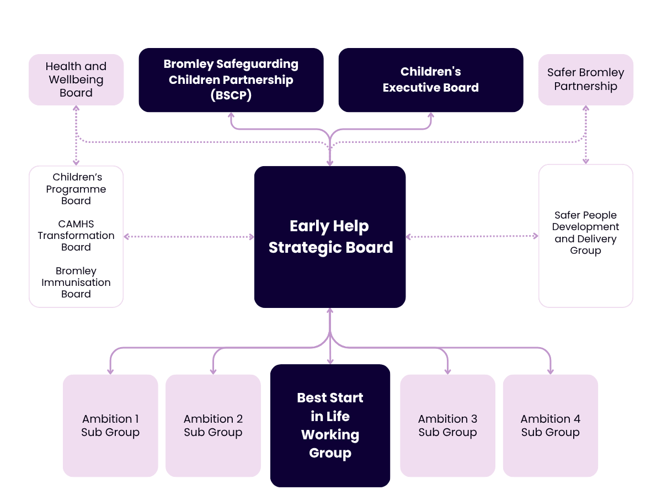

Appendix A: Digging deeper - Good Level of Development

A GLD in the EYFS is a statutory measure of child attainment at the end of Reception, signifying they are well-prepared for Year 1. Children reach GLD by meeting the "expected" level in 12 Early Learning Goals across 5 areas:

- Personal, social and emotional development (Prime Area)
- Physical (Prime Area)
- Communication (Prime Area)
- Literacy
- Mathematics

The picture in Bromley in 2024/25

Overall

- 2024/25 - 73.3% (+5.0% vs National)
- 2027/28 - 80.0% Target (Overall)
- 249 additional children achieving GLD to meet target

Free School Meals (FSM)

- 2024/25 - 52.3% (+1.1% vs National FSM)
- 2027/28 - 61.5% Target (FSM)
- 31 additional children achieving GLD to meet target

Gender

- Girls – 79.3%
- Boys – 67.7%

Term of birth

- Autumn – 78.5%
- Spring – 75.1%
- Summer – 67.9%

First language

- English – 75.3%
- Other than English – 67.3%

Ethnic heritage

- White – 73.7%
- Asian/Asian British – 76.4%
- Black/African/Caribbean – 66.0%
- Mixed/Multiple ethnic groups – 77.6%
- Other – 64.5%

Special educational needs

- SEN – 22.7%
- No SEN provision – 80.1%

Appendix B: Digging deeper - ASQ-3 assessment

The Ages & Stages Questionnaires®, Third Edition (ASQ-3™), is a parent-completed developmental screening tool used during the 2-2½ year health reviews.

It evaluates five key domains to monitor development and identify potential delays:

- Communication
- Gross motor
- Fine motor
- Problem-solving
- Personal-social

The picture in Bromley in 2024/25

Overall

- 82.9% of children were at or above the expected level in all five areas of development (+1.5% vs National)
- 89.2% of children received the ASQ-3 as part of the Healthy Child Programme or integrated review (where there are clear special needs this is not the appropriate tool)

Appendix C: Vaccinations and immunisations

Uptake of the 6-in-1 vaccine

The 6-in-1 vaccine is a combined DTaP IPV Hib HepB vaccine. It is the first in a course of vaccines offered to babies to protect them against diphtheria, pertussis (whooping cough), tetanus, Haemophilus influenzae type b (an important cause of childhood meningitis and pneumonia), polio (IPV is inactivated polio vaccine) and Hepatitis B.

6-in-1 at 12 months

The percentage of 1-year-olds in Bromley who have received the 6-in-1 vaccine has been consistently above 90%. There has been a general downward trend in update during that. There was a further small decrease last year where the percentage fell from 92.1% in 2023/24 to 91.2% in 2024/25. Whilst this is still above the London average of 86.3%, it is below the national average of 91.3%.

Uptake of MMR vaccinations

MMR is the combined vaccine that protects against measles, mumps and rubella. The first MMR vaccine is given to children as part of the routine vaccination schedule, usually within a month of their first birthday. They'll then have a booster dose before starting school, which is usually between three and five years of age.

MMR 2-year-olds

The percentage of 2-year-olds in Bromley who have received the MMR vaccine has been consistently around 90% during the past decade. There was a small decrease last year where the percentage fell from 90.0% in 2023/24 to 88.2% in 2024/25. Whilst this is still above the London average of 80.8%, it is below the national average of 88.9%.

MMR 5-year-olds (one dose)

Whilst the percentage of 5-year-olds in Bromley who have received a single dose of the MMR vaccine has been consistently above 90% during the past decade, there has been downward trend in uptake during that time. There was a further decrease last year where the percentage fell from 91.3% in 2023/24 to 90.5% in 2024/25. Whilst this is still above the London average of 84.4%, it is below the national average of 91.8%.

MMR 5-year-olds (two doses)

The percentage of 5-year-olds in Bromley who have received two doses of the MMR vaccine has been consistently between 86-90% during the past decade, there has been downward trend in uptake since 2018/19. There was a large decrease last year where the percentage fell from 86.1% in 2023/24 to 77.7% in 2024/25. Whilst this is still above the London average of 69.6%, it is below the national average of 83.7%.

https://explore-education-statistics.service.gov.uk/find-statistics/special-educational-needs-in-england/2024-25

